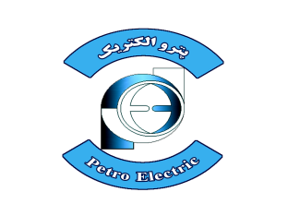 | CONCEPTUAL, BASIC and DETAIL DESIGN ENGINEERING OF STYRENE PARK OFFSITE | 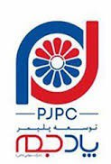
 | INSPECTION NOTIFICATION No. 12

From: Petro Electric
Tel: 021-88364512-88373529-88373531
To: Polymer Pad Jam Co.
Attn:
Project: OFFSITE
Subject: Request for Inspection
Ref .No.
Date: 2024-Dec-09

P.O No.
No
1 | Item(s) and Quantity subject to inspection : |  | Items | Quantity
1 |  |  | Compressor Skids including Bare Compressor, Main and Auxiliary Motors, Oil pump, Oil Filter, Piping, Oil Separator, Valves | 2 Sets
2 | Inspection Activities (reference to inspection plan)
  Dimensional and Visual Inspection
  Row No (ITP): 4,5,6,9 (without Instrumentation)
3 | Proposed Inspection date: |  | 2024-Dec-19
4 | VENDOR | Purchaser | Petro Electric
4 | VENDOR | Vendor | Delta GmbH- Mayekawa Middle East
4 | VENDOR | Person in Charge | Mr. Shoarian – Ms, Sherah Lyn
4 | VENDOR | E-mail address | planning@delta-gmbh.eu
4 | VENDOR | Tel: | 09126273626 - +971 4 8886363
4 | VENDOR | Fax:
5 | Place of Inspection (Full address) |  | P.O. Box 61349 | W-HOUSE No.RA-08-UC06, Jebel Ali Free Zone | United Arab Emirates - MAYEKAWA MIDDLE EAST FZCO  .
Petro Electric Inspection Department
Inspection Department:
Sign & Stamp

