STYRENE PARK OFFSITE

Document Title:
Steel Structure Calculation
NATIVE FILE ATTACHED

R1 | 22-07-2024 | IFA | J.morsali | J.Beigloo | A.Gholizadeh
R0 | 01-07-2024 | IFA | J.morsali | J.Beigloo | A.Gholizadeh
Rev. | Issued Date | DESCRIPTION | PREPARED | CHECKED | APPROVED

REVISION RECORD SHEET
Page | Revisions |  |  |  |  |  |  |  | Page | Revisions
Page | R0 | R1 | R2 | R3 | R4 | R5 | R6 |  | Page | R0 | R1 | R2 | R3 | R4 | R5 | R6
1 | X | X |  |  |  |  |  |  | 41
2 | X |  |  |  |  |  |  |  | 42
3 | X |  |  |  |  |  |  |  | 43
4 | X |  |  |  |  |  |  |  | 44
5 | X |  |  |  |  |  |  |  | 45
6 | X |  |  |  |  |  |  |  | 46
7 | X |  |  |  |  |  |  |  | 47
8 | X |  |  |  |  |  |  |  | 48
9 | X |  |  |  |  |  |  |  | 49
10 | X |  |  |  |  |  |  |  | 50
11 | X |  |  |  |  |  |  |  | 51
12 | X | X |  |  |  |  |  |  | 52
13 | X |  |  |  |  |  |  |  | 53
14 | X |  |  |  |  |  |  |  | 54
15 | X |  |  |  |  |  |  |  | 55
16 | X |  |  |  |  |  |  |  | 56
17 | X |  |  |  |  |  |  |  | 57
18 | X |  |  |  |  |  |  |  | 58
19 | X |  |  |  |  |  |  |  | 59
20 | X |  |  |  |  |  |  |  | 60
21 | X |  |  |  |  |  |  |  | 61
22 | X |  |  |  |  |  |  |  | 62
23 | X |  |  |  |  |  |  |  | 63
24 | X |  |  |  |  |  |  |  | 64
25 | X |  |  |  |  |  |  |  | 65
26 | X |  |  |  |  |  |  |  | 66
27 | X |  |  |  |  |  |  |  | 67
28 | X |  |  |  |  |  |  |  | 68
29 | X |  |  |  |  |  |  |  | 69
30 | X |  |  |  |  |  |  |  | 70
31 | X |  |  |  |  |  |  |  | 71
32 | X |  |  |  |  |  |  |  | 72
33 | X |  |  |  |  |  |  |  | 73
34 | X |  |  |  |  |  |  |  | 74
35 | X |  |  |  |  |  |  |  | 75
36 | X | X |  |  |  |  |  |  | 76
37 | X | X |  |  |  |  |  |  | 77
38 | X |  |  |  |  |  |  |  | 78
39 | X |  |  |  |  |  |  |  | 79
40 |  |  |  |  |  |  |  |  | 80

TABLE OF CONTENTS
Table of Content:
1. SCOPE 4
2. CODE AND STANDARDS 4
3. REFERENCE DRAWING AND GENERAL DOCUMENT 4
4. MATERIAL 4
5. AIR COLLER TYPE 4
5.1. Weight Data 5
6. EXTERNAL LOADS 5
6.1. LOAD CASE DEFINITION 5
6.2. DEAD LOAD 6
6.2.1. Bundle dry reaction according to table 1: 6
6.2.2. weight of Attachment in FORCED Draft according to table 1: 7
6.2.3. Bundle Reaction Due to Fluid (WATER) Weight according to table 1: 7
6.2.4. Nozzle Load acc. to API 661 (1×4”) 8
6.2.5. Dead Load of Handrail & Grating 9
6.3. LIVE LOAD 10
6.4. SNOW LOAD 11
6.5. SEISMIC LOAD 12
6.6. WIND LOAD 12
7. BASE PLATE & ANCHOR BOLT DESIGN 13
8. DESIGN & ANALSIS 23
9. COMBINATION 31
10. JOINT REACTION 36
11. Steel Design 37
12. Story Drift & Deflection Control 40

- SCOPE
This calculation book covers a structural design for AIR COOLERS FOR Asalouyeh Project (ITEM: 1158). 3Dimensional model analyzed by mean of SAP 2000 (version 20.2.0.). This report contains computerized model, load evaluation and design verification.
- CODE AND STANDARDS
- ASCE7-16, AISC360-16, INBC, PART 6, Standard NO 2800
- REFERENCE DRAWING AND GENERAL DOCUMENT
- Air Cooler General Arrangement : EI027-DMF-VD-ME-DWG-003
- MATERIAL
- Structural Steel: ST37 with Fy = 2400 kgf/cm2, Fu = 3700 kg/cm2
- Setting Bolts: A325 with Fu = 8000 kgf/cm2

- AIR COLLER TYPE
- Descriptions of Supported Equipment → Draft: FORCED

Table 1. Weight of equipments For 1 Units ( Total Units = 2)
 | Total No in one Unit | Total Weight in one Unit (tonf) | Total No. for One Bay | Weight for One Bay (kgf)
Bundle Frame | 1 | 0.865 | 1 | 865
Tube Bundle & Headers | 1 | 2.635 | 1 | 2635
sum |  |  |  | 3500
Water in Tubes & Headers | 1 | 0.48 | 1 | 480
sum |  |  |  | 480
Plenum | 2 | 0.245 | 2 | 490
Fan Ring | 2 | 0.13 | 2 | 260
Motor | 2 | 0.07 | 2 | 140
Fan | 2 | 0.0275 | 2 | 55
Speed Reducer | 2 | 0.25 | 2 | 500
Machinery Mount | 2 | 0.32 | 2 | 640
Fan Guard | 2 | 0.0325 | 2 | 65
sum |  |  |  | 2150

6 .EXTERNAL LOADS

6.1. LOAD CASE DEFINITION:
DEAD: Dead load contain weight of component (bundle dry, plenum, fan ring, fan, fan guard, motor, Speed Reducer and Machinery Mount,), dead load of walkway
DEAD-OP: weight of liquid (water) within each tube bundle
DEADS: self-weight of steel structure
DEADN: nozzle load (3 times of API)
LIVE: live load of walkway.
EQX: effect of earth quake at x- direction.
EQY: effect of earth quake at y- direction.
EQXO: Amplified Seismic Load in X Dir. (2EQX )
EQYO: Amplified Seismic Load in Y Dir. (2 EQY)
WX: effect of wind load at x- direction.
WY: effect of wind load at y- direction.
SNOW: Snow Load

6.2. DEAD LOAD
There are one bundle per each bay

6.2.1. Bundle dry according to table 1 & table 1: (figure.1)
Tube bundle , Headers and bundle frame Weight per Item (Dry): 3.5 ton
Tube bundle , Headers and bundle frame Weight of Each Bundle (Dry): 3500 kg → Wd = 3500÷(8)=437.5 kg
→ Wd = = 437.5 kg , (Point load on transvers beams)

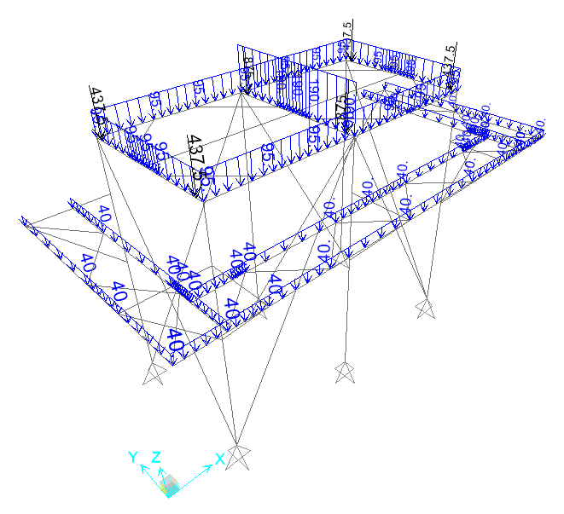
Figure.1
6.2.2. Weight of Attachment in FORCED Draft according to table 1: (figure.1)
TOTAL Wequipment for Item = 2150 kg (for 1 Bay)
Wequipment =1075 kg (for One Unit)
L=5.7 m, W=2.8 m→L+2W=11.3 m
Distribution Load : Wequipment =1075/11.3= 95 kg/m

6.2.3. Bundle Reaction Due to Fluid (WATER) Weight according to table 1: (figure.2)
Weight per one unit Item (Operation: Only fluid Weight): 0.48 ton
Weight of each bundle (Operation: Only fluid Weight): 480 kg → Wo = 480÷8=60 kg → Wo = ~60 kg (Point load on transvers beams)
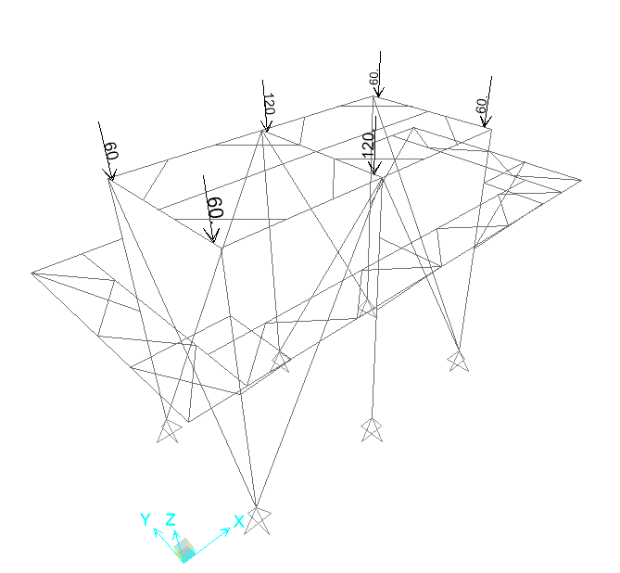
Figure.2
6.2.4. Nozzle Load Acc. to API 661:(figure .3)

Table 2. Nozzle Load for Size 4”
Nozzle Direction | Structure Direction | API Load (kgf) |  | 3×API | Nozzlele  QTY. | Final Load
x | x | F_{x} = | 334 | 1002 | 1 | 1002
y | z | F_{y} = | 267 | 801 | 1 | 801
z | y | F_{z} = | 334 | 1002 | 1 | 1002

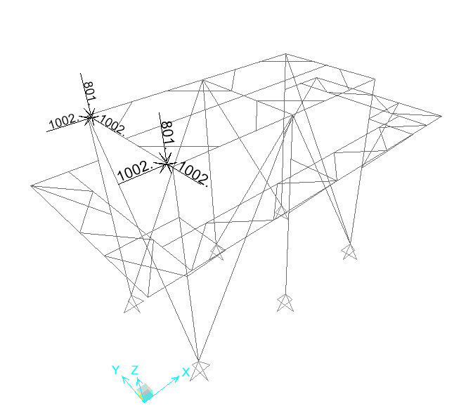
Figure.3
6.2.5. Dead Load of Handrail & Grating: (figure.4)
Weight of Grating = 45 kg/m²
Walkway Frame = 40 kg/m²
Handrail = 15 kg/m²
Width of Walkway = 0.8 m
Dead load for Walkway Beams = (45+40+15) × (0.75÷2) = 37.5 kg/m → USE: 40 kg/m

Figure.4

6.3. LIVE LOAD (figure.5)
Live Load According to API 661: 250 kg/m²
Live Load for Walkway Beams (Bearing width = 0.75÷2=0.375 m): 100 kg/m → USE: 100kg/m

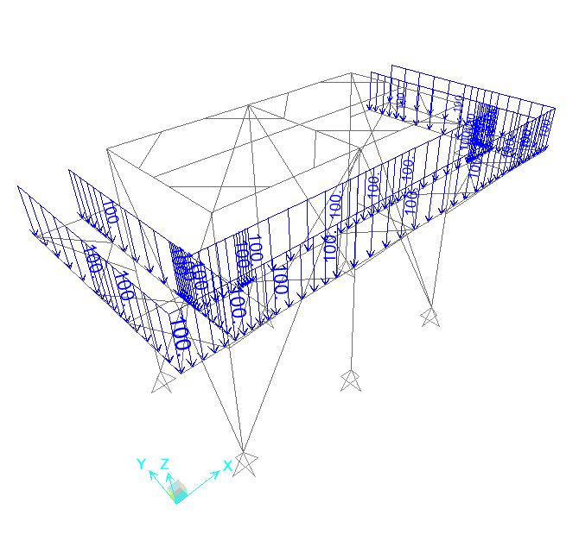
Figure.5

6.4. SNOW LOAD (Figure.6)
According to INBC Part 6:
Ground Snow Loads, Ps = 50 kg/m²
Importance factor, Is = 1.2
Exposure factor, Cn = 1.1
Thermal factor, Ch = 1.0
Slope factor, Cs = 1.0
P_{r} = I_{s} C_{n} C_{h} C_{S} P_{g} → Pr =1.2×1.1×1.0×1.0×50 = 66 kg/m²
Effective Area: 2.497×(6.33) = 15.81 m²
F_{snow} = 66×15.81 → F_{snow} = 1044 kg → W_{s} = 1044÷(8) → W_{s} = 131 kg (Point Load on Transverse beams)
Snow load for Walk Way Beams = 66×0..375 = 25 kg/m
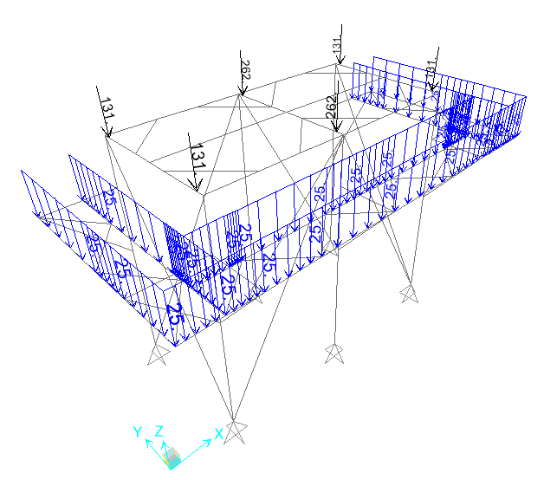
Figure.6

6.5. SEISMIC LOAD
Air cooler support (steel structure) designed in accordance with Standard Standard NO 2800:
According to Standard NO 2800 : Soil Type = IV & A=0.3, I=1.4 , R=3.5
According to Standard No 2800:
T=0.08H^{0.75} =0.27s
T₀= 0.15 , T_{s}=1 → B=2.75
$$C=\frac{ABI}{R}W=0.33W$$
W= tube bundles (full of water)+ weight of all equipment (plenums+ fan guards+ fan Rings+ fans+ motor+ speed reducers) + self-weight of structure + nozzle load+ 0.2(access platform load+ Snow) = 12078.6 kg
Seismic base shear:
→For Ordinary braced frame V = 0.33 *12.0786= 3.9859ton
For Ordinary braced frame:
Table 6. Mass Source for one Unit (Total Units=2)
Output Case | Global FZ (Tonf) | Multiplier | Mass Source
DEAD | 6.095 | 1 | 6.095
DEAD-OP | 0.48 | 1 | 0.48
DEAD-S | 3.412 | 1 | 3.412
DEAD-N | 1.602 | 1 | 1.602
LIVE | 1.12 | 0.2 | 0.224
SNOW | 1.328 | 0.2 | 0.2656
Sum |  |  | 12.0786

6.6. WIND LOAD
Auto WIND used for Columns, Bracing and Walkway According to ASCE 7-16
Acc.to Client Spec, Basic wind velocity = 125 Km/hr & Exposure Category: C

7.7 BASE PLATE & ANCHOR BOLT DESIGN
Design
Name | Base Plate Connection
Description
Analysis | Stress, strain/ simplified loading
Design code | AISC - LRFD (2022)
Members
Geometry
Name | Cross-section | β – Direction  [°] | γ - Pitch  [°] | α - Rotation  [°] | Offset ex  [mm] | Offset ey  [mm] | Offset ez  [mm]
COL | 1 - CON1(HEA160) | 0.0 | 90.0 | 0.0 | 0 | 0 | 0
Supports and forces
Name | Support | Forces in | X  [mm]
COL / end |  | Node | 0
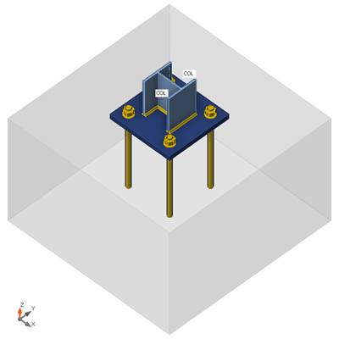

Cross-sections
Name | Material
1 - CON1(HEA160) | A36
Anchors
Name | Diameter  [mm] | f_{y}  [MPa] | f_{u}  [MPa] | Gross area  [mm²]
24 A325M | 24 | 660.0 | 830.0 | 452
Load effects (Equilibrium not required)
Name | Member | N  [kN] | Vy  [kN] | Vz  [kN] | Mx  [kNm] | My  [kNm] | Mz  [kNm]
LE1 | COL / End | -127.0 | 34.0 | 47.0 | 0.0 | 0.0 | 0.0
Foundation block
Item | Value | Unit
CB 1
Dimensions | 950 x 950 | mm
Depth | 600 | mm
Anchor | 24 A325M
Anchoring length | 400 | mm
Shear force transfer | Anchors
Check
Summary
Name | Value | Check status
Analysis | 100.0% | OK
Plates | 0.0 < 5.0% | OK
Anchors | 70.5 < 100% | OK
Welds | 29.8 < 100% | OK
Concrete block | 4.8 < 100% | OK
Buckling | Not calculated
Plates
Name | t_{p}  [mm] | Loads | σ_{Ed}  [MPa] | ε_{Pl}  [%] | σ_{c,Ed}  [MPa] | Status
COL-bfl 1 | 9.0 | LE1 | 164.8 | 0.0 | 0.0 | OK
COL-tfl 1 | 9.0 | LE1 | 97.1 | 0.0 | 0.0 | OK
COL-w 1 | 6.0 | LE1 | 116.6 | 0.0 | 0.0 | OK
BP1 | 25.0 | LE1 | 30.4 | 0.0 | 0.0 | OK
Design data
Material | F_{y}  [MPa] | ε_{lim}  [%]
A36 | 248.2 | 5.0
Symbol explanation
t_{p} | Plate thickness
σ_{Ed} | Equivalent stress
ε_{Pl} | Plastic strain
σ_{c,Ed} | Contact stress
F_{y} | Yield strength
ε_{lim} | Limit of plastic strain
Detailed result for COL-bfl 1
Design values used in the analysis
 | 223.4 | MPa
Where:
– characteristic yield strength
– resistance factor for steel material AISC 360-22 – B3.1

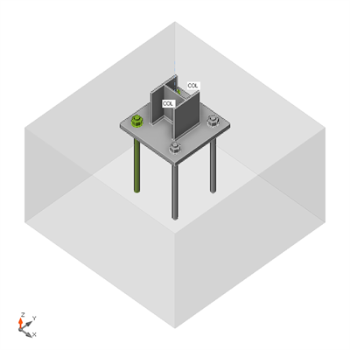  Overall check, LE1 |  | 
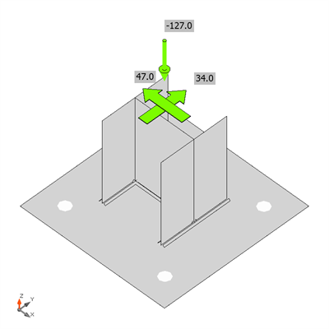  Strain check, LE1 | 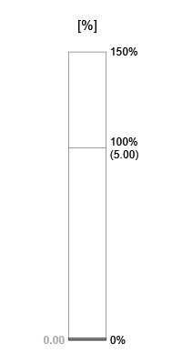

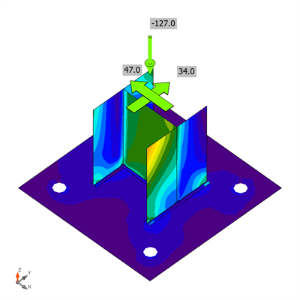  Equivalent stress, LE1 | 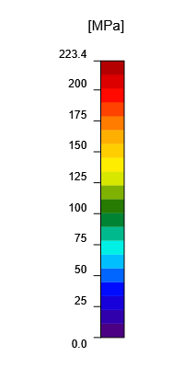

Shape | Item | Loads | N_{f}  [kN] | V  [kN] | ϕV_{cbg}  [kN] | ϕV_{cp}  [kN] | Ut_{t}  [%] | Ut_{s}  [%] | Ut_{ts}  [%] | Detailing | Status
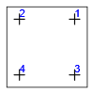 | A1 | LE1 | 0.0 | 14.8 | 70.9 | 444.6 | 0.0 | 70.5 | 55.8 | OK | OK
 | A2 | LE1 | 0.0 | 14.3 | 70.9 | 444.6 | 0.0 | 70.5 | 55.8 | OK | OK
 | A3 | LE1 | 0.0 | 14.3 | 77.9 | 444.6 | 0.0 | 53.1 | 34.8 | OK | OK
 | A4 | LE1 | 0.0 | 14.5 | - | 444.6 | 0.0 | 13.0 | 3.4 | OK | OK

Design data
Grade | ϕN_{sa}  [kN] | ϕV_{sa}  [kN]
24 A325M - 1 | 205.1 | 114.3
Symbol explanation
N_{f} | Tension force
V | Resultant of bolt shear forces Vy and Vz in shear planes
ϕV_{cbg} | Concrete breakout strength in shear – ACI 318-14 – 17.5.2
ϕV_{cp} | Concrete pryout strength in shear – ACI 318-14 – 17.5.3
Ut_{t} | Utilization in tension
Ut_{s} | Utilization in shear
Ut_{ts} | Utilization in tension and shear
ϕN_{sa} | Steel strength of anchor in tension - ACI 318-14 – 17.4.1
ϕV_{sa} | Steel strength of anchor in shear - ACI 318-14 – 17.5.1
Detailed result for A1
Anchor tensile resistance (ACI 318-14 – 17.4.1)
 | 205.1 | kN | ≥ |  | 0.0 | kN
Where:
– resistance factor
– tensile stress area
– specified tensile strength of anchor steel:
, where:
660.0 MPa – specified yield strength of anchor steel
830.0 MPa – specified ultimate strength of anchor steel

Shear resistance (ACI 318-14 – 17.5.1)
 | 114.3 | kN | ≥ |  | 14.8 | kN
Where:
– resistance factor
– tensile stress area
– specified tensile strength of anchor steel:
, where:
660.0 MPa – specified yield strength of anchor steel
830.0 MPa – specified ultimate strength of anchor steel

Concrete shear breakout check (ACI 318-14 – 17.5.2)
The check is performed for group of anchors that form common shear breakout cone: A1, A2
 | 70.9 | kN | ≥ |  | 50.0 | kN
Where:
– sum of shear forces of anchors on common base plate
– resistance factor
– projected concrete failure area of an anchor or group of anchors
– projected concrete failure area of one anchor when not limited by corner influences, spacing or member thickness
– modification factor for anchor groups loaded eccentrically in shear:
, where:
0 mm – shear load eccentricity
354 mm – edge distance in direction of the load
354 mm – edge distance in direction of the load
– modification factor for edge effect:
, where:
354 mm – edge distance in direction of the load
354 mm – edge distance in direction of the load
355 mm – edge distance in direction perpendicular to the load
– modification factor for concrete conditions
– modification factor for anchors located in a shallow concrete member:
, where:
600 mm – thickness of member in which an anchor is anchored measured parallel to anchor axis
– modification factor for anchors loaded at an angle with the concrete edge
, where:
19.9 ° – angle between direction of shear force and direction perpendicular to concrete edge
– basic concrete breakout strength of a single anchor in shear:
, where:
192 mm – effective length
24 mm – anchor diameter
1.00 – modification factor for lightweight concrete
27.6 MPa – concrete compressive strength
354 mm – edge distance in direction of the load
354 mm – edge distance in direction of the load

Concrete pryout resistance (ACI 318-14 – 17.5.3)
The check is performed for group of anchors on common base plate
 | 444.6 | kN | ≥ |  | 58.0 | kN
Where:
– resistance factor
– concrete pry-out factor
– concrete cone tension break-out resistance in case all anchors are in tension
– sum of shear forces of anchors on common base plate

Interaction of tensile and shear forces (ACI 318-14 – R17.6)
 | 0.56 | ≤ | 1.0
Where:
– maximum ratio of factored tensile force and tensile resistance determined from all appropriate failure modes
– maximum ratio of factored shear force and shear resistance determined from all appropriate failure modes

Welds
Item | Edge | Xu | t_{w}  [mm] | w  [mm] | L  [mm] | L_{c}  [mm] | Loads | F_{n}  [kN] | ϕR_{n}  [kN] | Ut  [%] | Detailing | Status
BP1 | COL-bfl 1 | E70xx | ◢ 4.9 ◣ | ◢ 7.0 ◣ | 159 | 13 | LE1 | 6.0 | 20.1 | 29.8 | OK | OK
 |  | E70xx | ◢ 4.9 ◣ | ◢ 7.0 ◣ | 159 | 13 | LE1 | 5.4 | 20.2 | 26.9 | OK | OK
BP1 | COL-tfl 1 | E70xx | ◢ 4.9 ◣ | ◢ 7.0 ◣ | 159 | 13 | LE1 | 4.7 | 19.8 | 23.6 | OK | OK
 |  | E70xx | ◢ 4.9 ◣ | ◢ 7.0 ◣ | 159 | 13 | LE1 | 4.1 | 19.4 | 21.2 | OK | OK
BP1 | COL-w 1 | E70xx | ◢ 4.9 ◣ | ◢ 7.0 ◣ | 142 | 13 | LE1 | 2.5 | 15.6 | 15.7 | OK | OK
 |  | E70xx | ◢ 4.9 ◣ | ◢ 7.0 ◣ | 142 | 13 | LE1 | 2.4 | 15.1 | 15.8 | OK | OK
Design data
Material | F_{exx}  [MPa]
E70xx | 482.6
Symbol explanation
t_{w} | Throat thickness of weld
w | Leg size of weld
L | Length of weld
L_{c} | Length of weld critical element
F_{n} | Force in weld critical element
ϕR_{n} | Weld resistance - AISC 360-22 – J2-4
Ut | Utilization
◢ | Fillet weld
F_{exx} | Ultimate strength as rated by electrode classification number
Detailed result for BP1 / COL-bfl 1
Weld resistance check (AISC 360-22 – J2-4)
 | 20.1 | kN | ≥ |  | 6.0 | kN
Where:
– nominal stress of weld material:
, where:
482.6 MPa – electrode classification number, i.e. minimum specified tensile strength
60.3° – angle of loading measured from the weld longitudinal axis
– effective area of weld critical element
– resistance factor for welded connections

Item | Loads | A₁  [mm²] | A₂  [mm²] | σ  [MPa] | ϕf_{p,max}  [MPa] | Ut  [%] | Status
CB 1 | LE1 | 86506 | 705173 | 1.5 | 30.5 | 4.8 | OK
Symbol explanation
A₁ | Loaded area
A₂ | Supporting area
σ | Average stress in concrete
ϕf_{p,max} | Concrete bearing resistance
Ut | Utilization
Detailed result for CB 1
Concrete block compressive resistance check (AISC 360-22 – J8)
 | 30.5 | MPa | ≥ |  | 1.5 | MPa
Where:
– concrete block design bearing strength:
, where:
27.6 MPa – concrete compressive strength
86506 mm² – base plate area in contact with concrete surface
705173 mm² – concrete supporting surface
– resistance factor for concrete


8. DESIGN & ANALYSIS

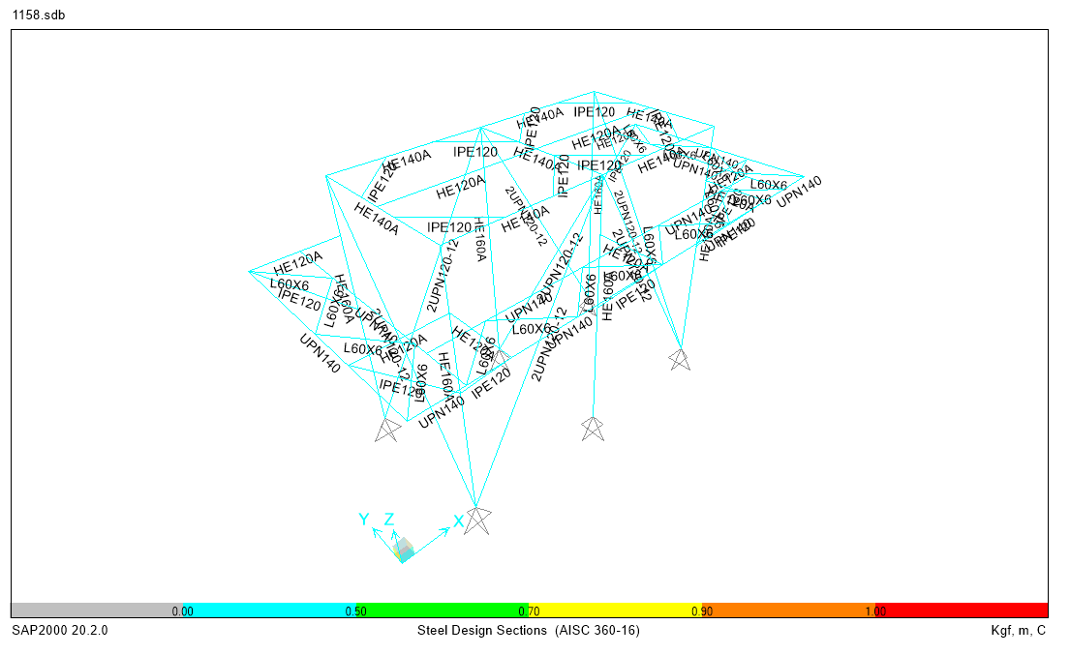

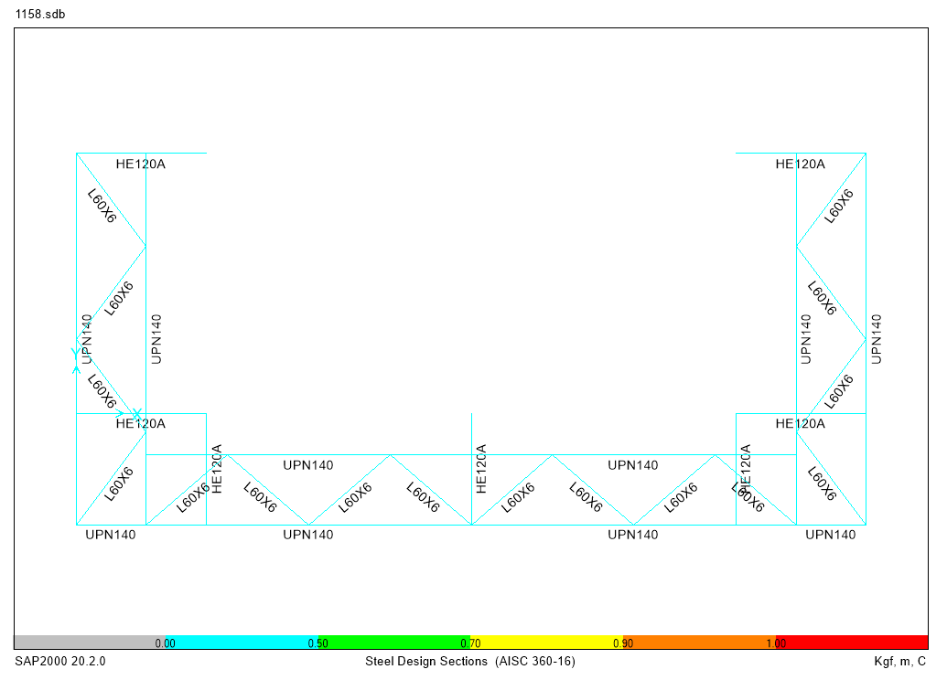

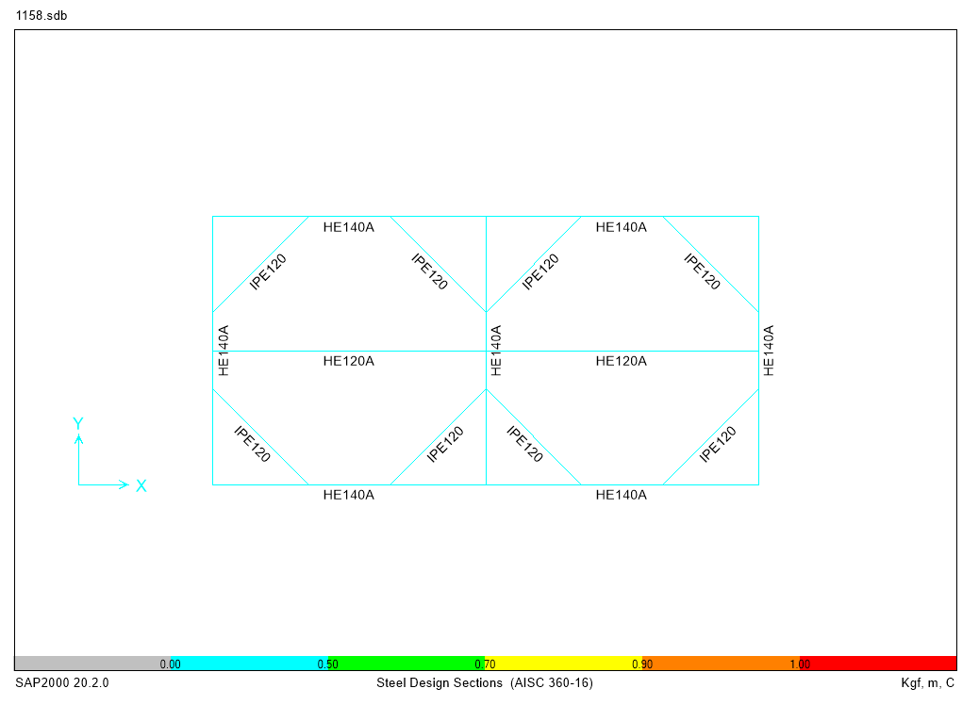

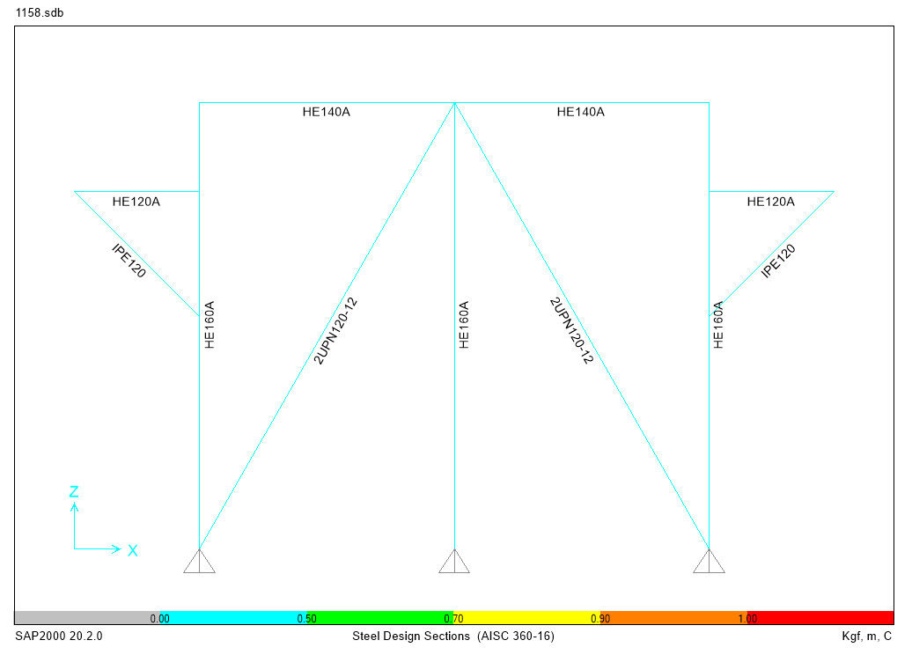

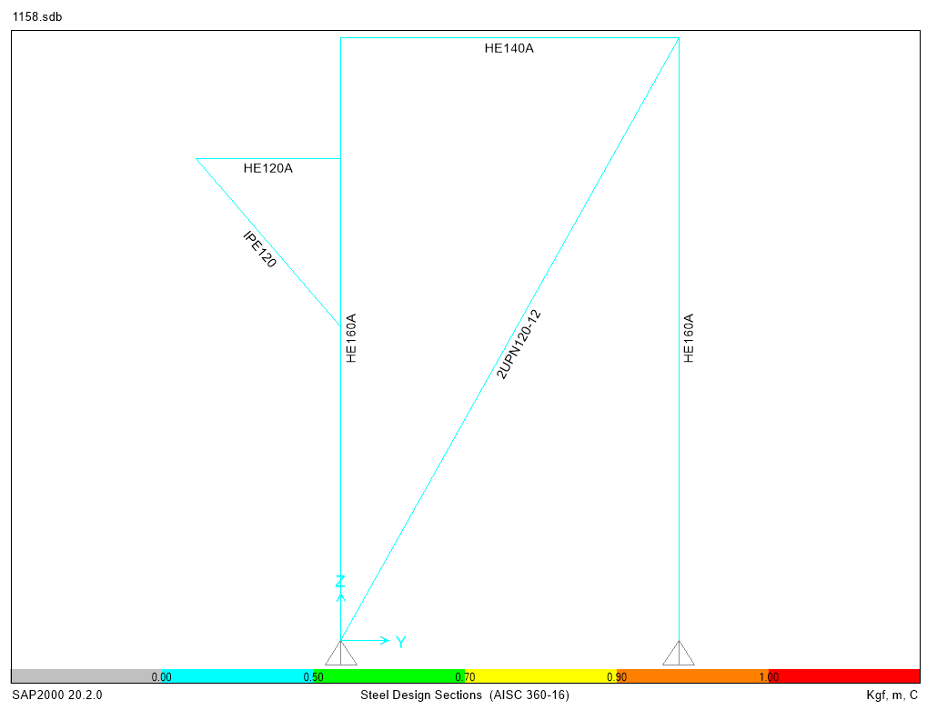

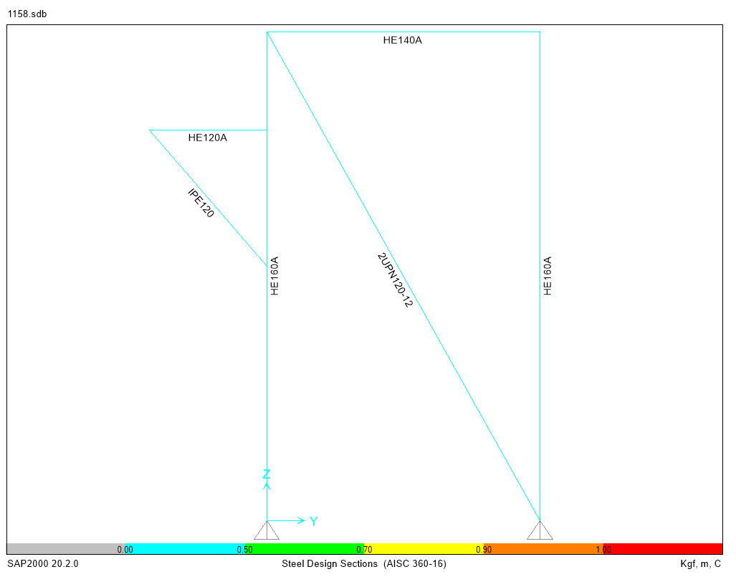

9. COMBINATION
Table: Combination Definitions, Part 1 of 3
Table: Combination Definitions, Part 1 of 3
ComboName | ComboType | AutoDesign | CaseType | CaseName | ScaleFactor | SteelDesign
COMB01 | Linear Add | No | Linear Static | DEAD_TOTAL | 1.4 | Strength
COMB02 | Linear Add | No | Linear Static | DEAD_TOTAL | 1.2 | Strength
COMB02 |  |  | Linear Static | LIVE | 1.6
COMB02 |  |  | Linear Static | SNOW | 0.5
COMB03 | Linear Add | No | Linear Static | DEAD_TOTAL | 1.2 | Strength
COMB03 |  |  | Linear Static | SNOW | 1.6
COMB03 |  |  | Linear Static | LIVE | 1
COMB04 | Linear Add | No | Linear Static | DEAD_TOTAL | 1.2 | Strength
COMB04 |  |  | Linear Static | SNOW | 1.6
COMB04 |  |  | Linear Static | WX | 0.7
COMB05 | Linear Add | No | Linear Static | DEAD_TOTAL | 1.2 | Strength
COMB05 |  |  | Linear Static | SNOW | 1.6
COMB05 |  |  | Linear Static | WX | -0.7
COMB06 | Linear Add | No | Linear Static | DEAD_TOTAL | 1.2 | Strength
COMB06 |  |  | Linear Static | SNOW | 1.6
COMB06 |  |  | Linear Static | WY | 0.7
COMB07 | Linear Add | No | Linear Static | DEAD_TOTAL | 1.2 | Strength
COMB07 |  |  | Linear Static | SNOW | 1.6
COMB07 |  |  | Linear Static | WY | -0.7
COMB08 | Linear Add | No | Linear Static | DEAD_TOTAL | 1.2 | Strength
COMB08 |  |  | Linear Static | WX | 1.4
COMB08 |  |  | Linear Static | LIVE | 1
COMB08 |  |  | Linear Static | SNOW | 0.5
COMB09 | Linear Add | No | Linear Static | DEAD_TOTAL | 1.2 | Strength
COMB09 |  |  | Linear Static | WX | -1.4
COMB09 |  |  | Linear Static | LIVE | 1
COMB09 |  |  | Linear Static | SNOW | 0.5
COMB10 | Linear Add | No | Linear Static | DEAD_TOTAL | 1.2 | Strength
COMB10 |  |  | Linear Static | WY | 1.4
COMB10 |  |  | Linear Static | LIVE | 1
COMB10 |  |  | Linear Static | SNOW | 0.5
COMB11 | Linear Add | No | Linear Static | DEAD_TOTAL | 1.2 | Strength
COMB11 |  |  | Linear Static | WY | -1.4
COMB11 |  |  | Linear Static | LIVE | 1
COMB11 |  |  | Linear Static | SNOW | 0.5
COMB12 | Linear Add | No | Linear Static | DEAD_TOTAL | 0.9 | Strength
COMB12 |  |  | Linear Static | WX | 1.4
COMB13 | Linear Add | No | Linear Static | DEAD_TOTAL | 0.9 | Strength
COMB13 |  |  | Linear Static | WX | -1.4
COMB14 | Linear Add | No | Linear Static | DEAD_TOTAL | 0.9 | Strength
COMB14 |  |  | Linear Static | WY | 1.4
COMB15 | Linear Add | No | Linear Static | DEAD_TOTAL | 0.9 | Strength
COMB15 |  |  | Linear Static | WY | -1.4
E_COMB01 | Linear Add | No | Linear Static | DEAD_TOTAL | 1.365 | Strength
E_COMB01 |  |  | Linear Static | EQX | 1
E_COMB01 |  |  | Linear Static | LIVE | 1
E_COMB01 |  |  | Linear Static | SNOW | 0.2
E_COMB02 | Linear Add | No | Linear Static | DEAD_TOTAL | 1.365 | Strength
E_COMB02 |  |  | Linear Static | EQX | -1
E_COMB02 |  |  | Linear Static | LIVE | 1
E_COMB02 |  |  | Linear Static | SNOW | 0.2
E_COMB03 | Linear Add | No | Linear Static | DEAD_TOTAL | 1.365 | Strength
E_COMB03 |  |  | Linear Static | EQY | 1
E_COMB03 |  |  | Linear Static | LIVE | 1
E_COMB03 |  |  | Linear Static | SNOW | 0.2
E_COMB04 | Linear Add | No | Linear Static | DEAD_TOTAL | 1.365 | Strength
E_COMB04 |  |  | Linear Static | EQY | -1
E_COMB04 |  |  | Linear Static | LIVE | 1
E_COMB04 |  |  | Linear Static | SNOW | 0.2
E_COMB05 | Linear Add | No | Linear Static | DEAD_TOTAL | 0.735 | Strength
E_COMB05 |  |  | Linear Static | EQX | 1
E_COMB06 | Linear Add | No | Linear Static | DEAD_TOTAL | 0.735 | Strength
E_COMB06 |  |  | Linear Static | EQX | -1
E_COMB07 | Linear Add | No | Linear Static | DEAD_TOTAL | 0.735 | Strength
E_COMB07 |  |  | Linear Static | EQY | 1
E_COMB08 | Linear Add | No | Linear Static | DEAD_TOTAL | 0.735 | Strength
E_COMB08 |  |  | Linear Static | EQY | -1
E_COMB09 | Linear Add | No | Linear Static | DEAD_TOTAL | 1.365 | Strength
E_COMB09 |  |  | Linear Static | EQX | 1
E_COMB09 |  |  | Linear Static | LIVE | 1
E_COMB09 |  |  | Linear Static | EQY | 0.3
E_COMB09 |  |  | Linear Static | SNOW | 0.2
E_COMB10 | Linear Add | No | Linear Static | DEAD_TOTAL | 1.365 | Strength
E_COMB10 |  |  | Linear Static | EQX | 1
E_COMB10 |  |  | Linear Static | LIVE | 1
E_COMB10 |  |  | Linear Static | EQY | -0.3
E_COMB10 |  |  | Linear Static | SNOW | 0.2
E_COMB11 | Linear Add | No | Linear Static | DEAD_TOTAL | 1.365 | Strength
E_COMB11 |  |  | Linear Static | EQX | -1
E_COMB11 |  |  | Linear Static | LIVE | 1
E_COMB11 |  |  | Linear Static | EQY | -0.3
E_COMB11 |  |  | Linear Static | SNOW | 0.2
E_COMB13 | Linear Add | No | Linear Static | DEAD_TOTAL | 1.365 | Strength
E_COMB13 |  |  | Linear Static | EQY | 1
E_COMB13 |  |  | Linear Static | LIVE | 1
E_COMB13 |  |  | Linear Static | EQX | 0.3
E_COMB13 |  |  | Linear Static | SNOW | 0.2
E_COMB14 | Linear Add | No | Linear Static | DEAD_TOTAL | 1.365 | Strength
E_COMB14 |  |  | Linear Static | EQY | 1
E_COMB14 |  |  | Linear Static | LIVE | 1
E_COMB14 |  |  | Linear Static | EQX | -0.3
E_COMB14 |  |  | Linear Static | SNOW | 0.2
E_COMB15 | Linear Add | No | Linear Static | DEAD_TOTAL | 1.365 | Strength
E_COMB15 |  |  | Linear Static | EQY | -1
E_COMB15 |  |  | Linear Static | LIVE | 1
E_COMB15 |  |  | Linear Static | EQX | -0.3
E_COMB15 |  |  | Linear Static | SNOW | 0.2
E_COMB16 | Linear Add | No | Linear Static | DEAD_TOTAL | 1.365 | Strength
E_COMB16 |  |  | Linear Static | EQY | -1
E_COMB16 |  |  | Linear Static | LIVE | 1
E_COMB16 |  |  | Linear Static | EQX | 0.3
E_COMB16 |  |  | Linear Static | SNOW | 0.2
E_COMB17 | Linear Add | No | Linear Static | DEAD_TOTAL | 0.735 | Strength
E_COMB17 |  |  | Linear Static | EQX | 1
E_COMB17 |  |  | Linear Static | EQY | 0.3
E_COMB18 | Linear Add | No | Linear Static | DEAD_TOTAL | 0.735 | Strength
E_COMB18 |  |  | Linear Static | EQX | 1
E_COMB18 |  |  | Linear Static | EQY | -0.3
E_COMB19 | Linear Add | No | Linear Static | DEAD_TOTAL | 0.735 | Strength
E_COMB19 |  |  | Linear Static | EQX | -1
E_COMB19 |  |  | Linear Static | EQY | -0.3
E_COMB20 | Linear Add | No | Linear Static | DEAD_TOTAL | 0.735 | Strength
E_COMB20 |  |  | Linear Static | EQX | -1
E_COMB20 |  |  | Linear Static | EQY | 0.3
E_COMB21 | Linear Add | No | Linear Static | DEAD_TOTAL | 0.735 | Strength
E_COMB21 |  |  | Linear Static | EQY | 1
E_COMB21 |  |  | Linear Static | EQX | 0.3
E_COMB22 | Linear Add | No | Linear Static | DEAD_TOTAL | 0.735 | Strength
E_COMB22 |  |  | Linear Static | EQY | 1
E_COMB22 |  |  | Linear Static | EQX | -0.3
E_COMB23 | Linear Add | No | Linear Static | DEAD_TOTAL | 0.735 | Strength
E_COMB23 |  |  | Linear Static | EQY | -1
E_COMB23 |  |  | Linear Static | EQX | -0.3
E_COMB24 | Linear Add | No | Linear Static | DEAD_TOTAL | 0.735 | Strength
E_COMB24 |  |  | Linear Static | EQY | -1
E_COMB24 |  |  | Linear Static | EQX | 0.3
E_COMB12 | Linear Add | No | Linear Static | DEAD_TOTAL | 1.365 | Strength
E_COMB12 |  |  | Linear Static | EQX | -1
E_COMB12 |  |  | Linear Static | LIVE | 1
E_COMB12 |  |  | Linear Static | EQY | 0.3
E_COMB12 |  |  | Linear Static | SNOW | 0.2
ES_COMB01 | Linear Add | No | Linear Static | DEAD_TOTAL | 1.365 | Strength
ES_COMB01 |  |  | Linear Static | EQXO | 1
ES_COMB01 |  |  | Linear Static | LIVE | 1
ES_COMB01 |  |  | Linear Static | SNOW | 0.2
ES_COMB02 | Linear Add | No | Linear Static | DEAD_TOTAL | 1.3 | Strength
ES_COMB02 |  |  | Linear Static | EQXO | -1
ES_COMB02 |  |  | Linear Static | LIVE | 1
ES_COMB02 |  |  | Linear Static | SNOW | 0.2
ES_COMB03 | Linear Add | No | Linear Static | DEAD_TOTAL | 1.365 | Strength
ES_COMB03 |  |  | Linear Static | EQYO | 1
ES_COMB03 |  |  | Linear Static | LIVE | 1
ES_COMB03 |  |  | Linear Static | SNOW | 0.2
ES_COMB04 | Linear Add | No | Linear Static | DEAD_TOTAL | 1.365 | Strength
ES_COMB04 |  |  | Linear Static | EQYO | -1
ES_COMB04 |  |  | Linear Static | LIVE | 1
ES_COMB04 |  |  | Linear Static | SNOW | 0.2
ES_COMB05 | Linear Add | No | Linear Static | DEAD_TOTAL | 0.735 | Strength
ES_COMB05 |  |  | Linear Static | EQXO | 1
ES_COMB06 | Linear Add | No | Linear Static | DEAD_TOTAL | 0.735 | Strength
ES_COMB06 |  |  | Linear Static | EQXO | -1
ES_COMB07 | Linear Add | No | Linear Static | DEAD_TOTAL | 0.735 | Strength
ES_COMB07 |  |  | Linear Static | EQYO | 1
ES_COMB08 | Linear Add | No | Linear Static | DEAD_TOTAL | 0.735 | Strength
ES_COMB08 |  |  | Linear Static | EQYO | -1
ES_COMB09 | Linear Add | No | Linear Static | DEAD_TOTAL | 1.365 | Strength
ES_COMB09 |  |  | Linear Static | EQXO | 1
ES_COMB09 |  |  | Linear Static | LIVE | 1
ES_COMB09 |  |  | Linear Static | EQYO | 0.3
ES_COMB09 |  |  | Linear Static | SNOW | 0.2
ES_COMB10 | Linear Add | No | Linear Static | DEAD_TOTAL | 1.365 | Strength
ES_COMB10 |  |  | Linear Static | EQXO | 1
ES_COMB10 |  |  | Linear Static | LIVE | 1
ES_COMB10 |  |  | Linear Static | EQYO | -0.3
ES_COMB10 |  |  | Linear Static | SNOW | 0.2
ES_COMB11 | Linear Add | No | Linear Static | DEAD_TOTAL | 1.365 | Strength
ES_COMB11 |  |  | Linear Static | EQXO | -1
ES_COMB11 |  |  | Linear Static | LIVE | 1
ES_COMB11 |  |  | Linear Static | EQYO | -0.3
ES_COMB11 |  |  | Linear Static | SNOW | 0.2
ES_COMB13 | Linear Add | No | Linear Static | DEAD_TOTAL | 1.365 | Strength
ES_COMB13 |  |  | Linear Static | EQYO | 1
ES_COMB13 |  |  | Linear Static | LIVE | 1
ES_COMB13 |  |  | Linear Static | EQXO | 0.3
ES_COMB13 |  |  | Linear Static | SNOW | 0.2
ES_COMB14 | Linear Add | No | Linear Static | DEAD_TOTAL | 1.365 | Strength
ES_COMB14 |  |  | Linear Static | EQYO | 1
ES_COMB14 |  |  | Linear Static | LIVE | 1
ES_COMB14 |  |  | Linear Static | EQXO | -0.3
ES_COMB14 |  |  | Linear Static | SNOW | 0.2
ES_COMB15 | Linear Add | No | Linear Static | DEAD_TOTAL | 1.365 | Strength
ES_COMB15 |  |  | Linear Static | EQYO | -1
ES_COMB15 |  |  | Linear Static | LIVE | 1
ES_COMB15 |  |  | Linear Static | EQXO | -0.3
ES_COMB15 |  |  | Linear Static | SNOW | 0.2
ES_COMB16 | Linear Add | No | Linear Static | DEAD_TOTAL | 1.365 | Strength
ES_COMB16 |  |  | Linear Static | EQYO | -1
ES_COMB16 |  |  | Linear Static | LIVE | 1
ES_COMB16 |  |  | Linear Static | EQXO | 0.3
ES_COMB16 |  |  | Linear Static | SNOW | 0.2
ES_COMB17 | Linear Add | No | Linear Static | DEAD_TOTAL | 0.735 | Strength
ES_COMB17 |  |  | Linear Static | EQXO | 1
ES_COMB17 |  |  | Linear Static | EQYO | 0.3
ES_COMB18 | Linear Add | No | Linear Static | DEAD_TOTAL | 0.735 | Strength
ES_COMB18 |  |  | Linear Static | EQXO | 1
ES_COMB18 |  |  | Linear Static | EQYO | -0.3
ES_COMB19 | Linear Add | No | Linear Static | DEAD_TOTAL | 0.735 | Strength
ES_COMB19 |  |  | Linear Static | EQXO | -1
ES_COMB19 |  |  | Linear Static | EQYO | -0.3
ES_COMB20 | Linear Add | No | Linear Static | DEAD_TOTAL | 0.735 | Strength
ES_COMB20 |  |  | Linear Static | EQXO | -1
ES_COMB20 |  |  | Linear Static | EQYO | 0.3
ES_COMB21 | Linear Add | No | Linear Static | DEAD_TOTAL | 0.735 | Strength
ES_COMB21 |  |  | Linear Static | EQYO | 1
ES_COMB21 |  |  | Linear Static | EQXO | 0.3
ES_COMB22 | Linear Add | No | Linear Static | DEAD_TOTAL | 0.735 | Strength
ES_COMB22 |  |  | Linear Static | EQYO | 1
ES_COMB22 |  |  | Linear Static | EQXO | -0.3
ES_COMB23 | Linear Add | No | Linear Static | DEAD_TOTAL | 0.735 | Strength
ES_COMB23 |  |  | Linear Static | EQYO | -1
ES_COMB23 |  |  | Linear Static | EQXO | -0.3
ES_COMB24 | Linear Add | No | Linear Static | DEAD_TOTAL | 0.735 | Strength
ES_COMB24 |  |  | Linear Static | EQYO | -1
ES_COMB24 |  |  | Linear Static | EQXO | 0.3
ES_COMB12 | Linear Add | No | Linear Static | DEAD_TOTAL | 1.365 | Strength
ES_COMB12 |  |  | Linear Static | EQXO | -1
ES_COMB12 |  |  | Linear Static | LIVE | 1
ES_COMB12 |  |  | Linear Static | EQYO | 0.3
ES_COMB12 |  |  | Linear Static | SNOW | 0.2
DEF_COMB1 | Linear Add | No | Linear Static | DEAD_TOTAL | 1 | Strength
DEF_COMB2 | Linear Add | No | Linear Static | LIVE | 1 | Strength
DEF_COMB3 | Linear Add | No | Linear Static | DEAD_TOTAL | 1 | Strength
DEF_COMB3 |  |  | Linear Static | LIVE | 1
DEF_COMB4 | Linear Add | No | Linear Static | DEAD_TOTAL | 1 | Strength
DEF_COMB4 |  |  | Linear Static | SNOW | 0.55
COMB00 | Linear Add | No | Linear Static | DEAD_TOTAL | 1.2 | Strength

10. JOINT REACTION

Table: Joint Reactions
Table: Joint Reactions
Joint | OutputCase | CaseType | F1 | F2 | F3 | M1 | M2 | M3
 |  |  | Kgf | Kgf | Kgf | Kgf-cm | Kgf-cm | Kgf-cm
A-1 | DEAD_S | LinStatic | 16.65 | -45 | 861.98 | 0 | 0 | 0
A-1 | DEAD | LinStatic | 49.34 | -158.83 | 1640.14 | 0 | 0 | 0
A-1 | DEAD_OP | LinStatic | 4.08 | -14.37 | 92.37 | 0 | 0 | 0
A-1 | DEAD_N | LinStatic | -1631.93 | 429.16 | -2881.5 | 0 | 0 | 0
A-1 | LIVE | LinStatic | 3.34 | 25.54 | 1383.73 | 0 | 0 | 0
A-1 | WX | LinStatic | 31.57 | 329.34 | -352.72 | 0 | 0 | 0
A-1 | WY | LinStatic | -387.76 | 93.94 | -669.09 | 0 | 0 | 0
A-1 | SNOW | LinStatic | 9.74 | -24.99 | 547.6 | 0 | 0 | 0
A-1 | EQX | LinStatic | 106.43 | 1146.34 | -1764.17 | 0 | 0 | 0
A-1 | EQY | LinStatic | -1561.76 | 337 | -3289.21 | 0 | 0 | 0
A-1 | EQXO | LinStatic | 210.24 | 2295.43 | -3529.78 | 0 | 0 | 0
A-1 | EQYO | LinStatic | -3123.79 | 673.24 | -6571.39 | 0 | 0 | 0
A-2 | DEAD_S | LinStatic | -20.6 | 1.599E-13 | 380.54 | 0 | 0 | 0
A-2 | DEAD | LinStatic | -33.06 | -2.89E-06 | 811.07 | 0 | 0 | 0
A-2 | DEAD_OP | LinStatic | -0.21 | -3.963E-07 | 55.27 | 0 | 0 | 0
A-2 | DEAD_N | LinStatic | -10.59 | -1.13 | -378.95 | 0 | 0 | 0
A-2 | LIVE | LinStatic | -76.47 | 6.353E-13 | 402.18 | 0 | 0 | 0
A-2 | WX | LinStatic | 1.165E-12 | 49.87 | 8.288E-13 | 0 | 0 | 0
A-2 | WY | LinStatic | -54.91 | -1.269E-13 | -353.83 | 0 | 0 | 0
A-2 | SNOW | LinStatic | -19.58 | -8.653E-07 | 221.21 | 0 | 0 | 0
A-2 | EQX | LinStatic | 0.004107 | 45.8 | 0.09216 | 0 | 0 | 0
A-2 | EQY | LinStatic | -48.82 | -0.38 | -1465.12 | 0 | 0 | 0
A-2 | EQXO | LinStatic | 0.00889 | 92.7 | 0.18 | 0 | 0 | 0
A-2 | EQYO | LinStatic | -98.54 | -0.78 | -2927.34 | 0 | 0 | 0
A-3 | DEAD_S | LinStatic | 16.65 | 45 | 861.98 | 0 | 0 | 0
A-3 | DEAD | LinStatic | 49.34 | 158.83 | 1640.17 | 0 | 0 | 0
A-3 | DEAD_OP | LinStatic | 4.08 | 14.37 | 92.37 | 0 | 0 | 0
A-3 | DEAD_N | LinStatic | 39.17 | 235.02 | 482.86 | 0 | 0 | 0
A-3 | LIVE | LinStatic | 3.34 | -25.54 | 1383.73 | 0 | 0 | 0
A-3 | WX | LinStatic | -31.57 | 329.34 | 352.72 | 0 | 0 | 0
A-3 | WY | LinStatic | -387.76 | -93.94 | -669.09 | 0 | 0 | 0
A-3 | SNOW | LinStatic | 9.74 | 24.99 | 547.61 | 0 | 0 | 0
A-3 | EQX | LinStatic | -106.49 | 1146.49 | 1764.07 | 0 | 0 | 0
A-3 | EQY | LinStatic | -1071.77 | -428.48 | -2570.23 | 0 | 0 | 0
A-3 | EQXO | LinStatic | -210.36 | 2295.75 | 3529.6 | 0 | 0 | 0
A-3 | EQYO | LinStatic | -2144 | -856.2 | -5134.3 | 0 | 0 | 0
B-1 | DEAD_S | LinStatic | 34.11 | -1.44 | 482.68 | 0 | 0 | 0
B-1 | DEAD | LinStatic | 174.23 | -2.24 | 983.92 | 0 | 0 | 0
B-1 | DEAD_OP | LinStatic | 16.3 | 0.03128 | 81.45 | 0 | 0 | 0
B-1 | DEAD_N | LinStatic | -670.87 | 1.33 | 2555.04 | 0 | 0 | 0
B-1 | LIVE | LinStatic | -43.74 | -6.51 | 64.14 | 0 | 0 | 0
B-1 | WX | LinStatic | -255.25 | 0.99 | -374.63 | 0 | 0 | 0
B-1 | WY | LinStatic | -1.33 | -70.96 | 504.74 | 0 | 0 | 0
B-1 | SNOW | LinStatic | 24.65 | -1.56 | 193.87 | 0 | 0 | 0
B-1 | EQX | LinStatic | -985.73 | 4.1 | -1834.5 | 0 | 0 | 0
B-1 | EQY | LinStatic | -51.12 | -28.6 | 2619.38 | 0 | 0 | 0
B-1 | EQXO | LinStatic | -1968.03 | 8.18 | -3658.39 | 0 | 0 | 0
B-1 | EQYO | LinStatic | -102.38 | -57.85 | 5233.15 | 0 | 0 | 0
B-2 | DEAD_S | LinStatic | -3.76E-15 | -9.82 | 342.79 | 0 | 0 | 0
B-2 | DEAD | LinStatic | -1.168E-10 | -61.15 | 847.79 | 0 | 0 | 0
B-2 | DEAD_OP | LinStatic | -1.602E-11 | -8.01 | 77.09 | 0 | 0 | 0
B-2 | DEAD_N | LinStatic | -0.0003857 | -403.24 | 720.08 | 0 | 0 | 0
B-2 | LIVE | LinStatic | 8.844E-15 | 82.81 | -147.91 | 0 | 0 | 0
B-2 | WX | LinStatic | -56.07 | 3.583E-12 | -6.399E-12 | 0 | 0 | 0
B-2 | WY | LinStatic | -8.004E-14 | -439.42 | 682.53 | 0 | 0 | 0
B-2 | SNOW | LinStatic | -3.498E-11 | 3.21 | 131.34 | 0 | 0 | 0
B-2 | EQX | LinStatic | 0.02819 | 0.04229 | -0.07544 | 0 | 0 | 0
B-2 | EQY | LinStatic | 0.006383 | -1570.51 | 2804.88 | 0 | 0 | 0
B-2 | EQXO | LinStatic | -0.2 | 0.08416 | -0.15 | 0 | 0 | 0
B-2 | EQYO | LinStatic | 0.0007535 | -3138.25 | 5603.81 | 0 | 0 | 0
B-3 | DEAD_S | LinStatic | -34.11 | -1.44 | 482.68 | 0 | 0 | 0
B-3 | DEAD | LinStatic | -174.23 | -2.24 | 983.9 | 0 | 0 | 0
B-3 | DEAD_OP | LinStatic | -16.3 | 0.03128 | 81.45 | 0 | 0 | 0
B-3 | DEAD_N | LinStatic | -670.07 | 1.26 | 1104.47 | 0 | 0 | 0
B-3 | LIVE | LinStatic | 43.74 | -6.51 | 64.14 | 0 | 0 | 0
B-3 | WX | LinStatic | -255.25 | -0.99 | 374.63 | 0 | 0 | 0
B-3 | WY | LinStatic | 1.33 | -70.96 | 504.74 | 0 | 0 | 0
B-3 | SNOW | LinStatic | -24.65 | -1.56 | 193.87 | 0 | 0 | 0
B-3 | EQX | LinStatic | -985.8 | -4.09 | 1834.58 | 0 | 0 | 0
B-3 | EQY | LinStatic | -40.75 | -28.68 | 1900.29 | 0 | 0 | 0
B-3 | EQXO | LinStatic | -1968.16 | -8.15 | 3658.54 | 0 | 0 | 0
B-3 | EQYO | LinStatic | -81.36 | -57.83 | 3796.07 | 0 | 0 | 0

11. Steel Design
Table: Steel Design 1 - Summary Data - AISC 360-16, Part 1 of 2
Table: Steel Design 1 - Summary Data - AISC 360-16, Part 1 of 2
Frame | DesignSect | DesignType | Status | Ratio | RatioType
99 | HE160A | Column | No Messages | 0.253046 | PMM
101 | HE160A | Column | No Messages | 0.054665 | PMM
102 | HE160A | Column | No Messages | 0.040064 | PMM
103 | HE160A | Column | No Messages | 0.261971 | PMM
104 | HE160A | Column | No Messages | 0.406105 | PMM
105 | HE140A | Beam | No Messages | 0.162303 | PMM
106 | HE140A | Beam | No Messages | 0.131533 | PMM
107 | HE140A | Beam | No Messages | 0.211858 | PMM
108 | HE140A | Beam | No Messages | 0.251346 | PMM
109 | HE140A | Beam | No Messages | 0.171418 | PMM
110 | HE140A | Beam | No Messages | 0.146359 | PMM
111 | HE140A | Beam | No Messages | 0.273511 | PMM
112 | 2UPN120-12 | Brace | No Messages | 0.375081 | PMM
113 | 2UPN120-12 | Brace | No Messages | 0.19283 | PMM
114 | 2UPN120-12 | Brace | No Messages | 0.182065 | PMM
115 | 2UPN120-12 | Brace | No Messages | 0.451008 | PMM
116 | 2UPN120-12 | Brace | No Messages | 0.20756 | PMM
117 | 2UPN120-12 | Brace | No Messages | 0.417087 | PMM
118 | 2UPN120-12 | Brace | No Messages | 0.171919 | PMM
119 | HE120A | Beam | No Messages | 0.13618 | PMM
120 | IPE120 | Brace | No Messages | 0.064215 | PMM
121 | HE120A | Beam | No Messages | 0.137819 | PMM
122 | IPE120 | Brace | No Messages | 0.064216 | PMM
123 | HE120A | Beam | No Messages | 0.139296 | PMM
124 | IPE120 | Brace | No Messages | 0.064217 | PMM
125 | HE120A | Beam | No Messages | 0.139809 | PMM
126 | IPE120 | Brace | No Messages | 0.064216 | PMM
127 | UPN140 | Beam | No Messages | 0.12311 | PMM
128 | UPN140 | Beam | No Messages | 0.132319 | PMM
129 | L60X6 | Beam | No Messages | 0.122285 | PMM
130 | L60X6 | Beam | No Messages | 0.122288 | PMM
131 | UPN140 | Beam | No Messages | 0.12312 | PMM
132 | UPN140 | Beam | No Messages | 0.132382 | PMM
133 | L60X6 | Beam | No Messages | 0.122283 | PMM
134 | L60X6 | Beam | No Messages | 0.122287 | PMM
135 | L60X6 | Beam | No Messages | 0.021851 | PMM
136 | L60X6 | Beam | No Messages | 0.021851 | PMM
137 | HE120A | Beam | No Messages | 0.037961 | PMM
138 | HE120A | Beam | No Messages | 0.040573 | PMM
139 | IPE120 | Beam | No Messages | 0.017324 | PMM
140 | IPE120 | Beam | No Messages | 0.02021 | PMM
141 | IPE120 | Beam | No Messages | 0.022546 | PMM
142 | IPE120 | Beam | No Messages | 0.014772 | PMM
143 | IPE120 | Beam | No Messages | 0.031597 | PMM
144 | IPE120 | Beam | No Messages | 0.025976 | PMM
145 | IPE120 | Beam | No Messages | 0.021312 | PMM
146 | IPE120 | Beam | No Messages | 0.036496 | PMM
147 | HE160A | Column | No Messages | 0.275513 | PMM

Table: Steel Design 1 - Summary Data - AISC 360-16, Part 2 of 2
Table: Steel Design 1 - Summary Data - AISC 360-16, Part 2 of 2
Frame | Combo | Location | ErrMsg | WarnMsg
 |  | m
99 | ES_COMB11 | 2.6 | No Messages | No Messages
101 | ES_COMB16 | 0 | No Messages | No Messages
102 | COMB08 | 2.5 | No Messages | No Messages
103 | ES_COMB10 | 2.6 | No Messages | No Messages
104 | ES_COMB13 | 2.6 | No Messages | No Messages
105 | ES_COMB16 | 1.8 | No Messages | No Messages
106 | ES_COMB11 | 1.85 | No Messages | No Messages
107 | ES_COMB09 | 1 | No Messages | No Messages
108 | ES_COMB12 | 1 | No Messages | No Messages
109 | ES_COMB12 | 1.85 | No Messages | No Messages
110 | ES_COMB10 | 1 | No Messages | No Messages
111 | ES_COMB14 | 1.8 | No Messages | No Messages
112 | ES_COMB10 | 2.87761 | No Messages | No Messages
113 | ES_COMB11 | 2.87761 | No Messages | No Messages
114 | ES_COMB13 | 2.86531 | No Messages | No Messages
115 | ES_COMB14 | 2.86531 | No Messages | No Messages
116 | ES_COMB16 | 0 | No Messages | No Messages
117 | ES_COMB09 | 2.87761 | No Messages | No Messages
118 | ES_COMB11 | 2.87761 | No Messages | No Messages
119 | ES_COMB15 | 0.65 | No Messages | No Messages
120 | COMB10 | 0.98995 | No Messages | No Messages
121 | ES_COMB13 | 0.65 | No Messages | No Messages
122 | COMB10 | 0.98995 | No Messages | No Messages
123 | ES_COMB14 | 0.65 | No Messages | No Messages
124 | COMB11 | 0.98995 | No Messages | No Messages
125 | ES_COMB16 | 0.65 | No Messages | No Messages
126 | COMB11 | 0.98995 | No Messages | No Messages
127 | COMB02 | 1.4 | No Messages | No Messages
128 | COMB02 | 1.4 | No Messages | No Messages
129 | ES_COMB13 | 0.79412 | No Messages | No Messages
130 | ES_COMB16 | 0.79412 | No Messages | No Messages
131 | COMB02 | 1.4 | No Messages | No Messages
132 | COMB02 | 1.4 | No Messages | No Messages
133 | ES_COMB14 | 0.79412 | No Messages | No Messages
134 | ES_COMB15 | 0.79412 | No Messages | No Messages
135 | ES_COMB09 | 0.375 | No Messages | No Messages
136 | ES_COMB12 | 0.375 | No Messages | No Messages
137 | COMB11 | 1.425 | No Messages | No Messages
138 | COMB11 | 1.425 | No Messages | No Messages
139 | ES_COMB10 | 0.4714 | No Messages | No Messages
140 | ES_COMB11 | 0.4714 | No Messages | No Messages
141 | ES_COMB09 | 0.94281 | No Messages | No Messages
142 | ES_COMB12 | 0.4714 | No Messages | No Messages
143 | ES_COMB12 | 0.4714 | No Messages | No Messages
144 | ES_COMB09 | 0.94281 | No Messages | No Messages
145 | ES_COMB11 | 0.4714 | No Messages | No Messages
146 | ES_COMB10 | 0.4714 | No Messages | No Messages
147 | ES_COMB14 | 2.6 | No Messages | No Messages

12. Story Drift & Deflection Control
According to ASCE7-16 Table 12.12-1 :
Allowable Story Drift For I & II Stroy = 0.025h
→ Cd*Δeu< 0.025*h → Δeu< 0.025*5000/3. 5 → Δeu< 35.7 mm
Cd=3. 5
Maximum Drift at 160 joint in Direction x = 1.61 mm < 35.7 mm ………………………………… (OK)
Maximum Drift at 160 joint in Direction y = 2.2 mm < 35.7 mm ………………………………… (OK)

DEFLECTION CONTROL:

Main Beam: Dmaximum =0.289 cm<L/500 (L=280)
Walkway Beam: Dmaximum =0.16 cm<L/300 (L=400)

