STYRENE PARK OFFSITE

Document Title:
Packing & Marking Procedure
R1 | 14-Oct.-2024 | IFA | A.Parsafar | A.Shadmand | M.heidarzadeh
R0 | 06-Oct.-2024 | IFA | A.Parsafar | A.Shadmand | M.heidarzadeh
Rev. | Issued Date | DESCRIPTION | PREPARED | CHECKED | APPROVED

REVISION RECORD SHEET
Page | Revisions |  |  |  |  |  |  |  | Page | Revisions
Page | R0 | R1 | R2 | R3 | R4 | R5 | R6 |  | Page | R0 | R1 | R2 | R3 | R4 | R5 | R6
1 | X | X |  |  |  |  |  |  | 41
2 | X | X |  |  |  |  |  |  | 42
3 | X | X |  |  |  |  |  |  | 43
4 | X | X |  |  |  |  |  |  | 44
5 | X | X |  |  |  |  |  |  | 45
6 | X | X |  |  |  |  |  |  | 46
7 | X | X |  |  |  |  |  |  | 47
8 | X | X |  |  |  |  |  |  | 48
9 | X | X |  |  |  |  |  |  | 49
10 | X | X |  |  |  |  |  |  | 50
11 | X | X |  |  |  |  |  |  | 51
12 | X | X |  |  |  |  |  |  | 52
13 | X | X |  |  |  |  |  |  | 53
14 | X | X |  |  |  |  |  |  | 54
15 |  |  |  |  |  |  |  |  | 55
16 |  |  |  |  |  |  |  |  | 56
17 |  |  |  |  |  |  |  |  | 57
18 |  |  |  |  |  |  |  |  | 58
19 |  |  |  |  |  |  |  |  | 59
20 |  |  |  |  |  |  |  |  | 60
21 |  |  |  |  |  |  |  |  | 61
22 |  |  |  |  |  |  |  |  | 62
23 |  |  |  |  |  |  |  |  | 63
24 |  |  |  |  |  |  |  |  | 64
25 |  |  |  |  |  |  |  |  | 65
26 |  |  |  |  |  |  |  |  | 66
27 |  |  |  |  |  |  |  |  | 67
28 |  |  |  |  |  |  |  |  | 68
29 |  |  |  |  |  |  |  |  | 69
30 |  |  |  |  |  |  |  |  | 70
31 |  |  |  |  |  |  |  |  | 71
32 |  |  |  |  |  |  |  |  | 72
33 |  |  |  |  |  |  |  |  | 73
34 |  |  |  |  |  |  |  |  | 74
35 |  |  |  |  |  |  |  |  | 75
36 |  |  |  |  |  |  |  |  | 76
37 |  |  |  |  |  |  |  |  | 77
38 |  |  |  |  |  |  |  |  | 78
39 |  |  |  |  |  |  |  |  | 79
40 |  |  |  |  |  |  |  |  | 80

Table of Contents

- PURPOSE
- SCOPE
- REFERENCES

- RESPONSIBILITY

- GENERAL REQUIREMENTS FOR PACKING

- PACKING PROCEDURE FOR TUBE BUNDLES

- PACKING PROCEDURE FOR STRUCTURAL PARTS

- Small Parts, Tools and spare Parts

- Format
1. PURPOSE
This procedure covers the requirements and instructions to be followed by the DAMAFIN for packing and marking of Air-cooled heat exchangers that will be procured in “Toase-ehe Park Sanati Gohar Ofogh Petrochemical Co. CONCEPTUAL, BASIC and DETAIL DESIGN ENGINEERING OF STYRENE PARK OFFSITE PROJECT”
2. SCOPE
This procedure is applicable for packing and shipping of tube bundles, machinery and steel structure parts of All Items.
3. REFERENCES
-DAMAFIN SPECIFICATION
-API 661
4. RESPONSIBILITY
DAMAFIN is solely responsible for packing and marking of goods.
5. GENERAL REQUIREMENTS FOR PACKING
The packing of the equipment and materials shall be carried out in order to comply with transport conditions, so it shall imply on following items:
5.1. The goods shall be dried, cleaned internally and externally, removed from all welded spatter ,scale, rust, cuttings, fittings, etc., as well as any all foreign material.
5.2. Protection against environmental corrosion caused by extremes of humidity, condensation, rain, dust, sand, salted air and sea spray shall be provided.
5.3. Packing means to efficiently protect the materials during the total transport operation:
5.4. High quality wooden cases and/or crates shall be used.

6. PACKING PROCEDURE FOR TUBE BUNDLES
6.1. Drying of Tube bundles
- Horizontal bundle to be lifted by 1 or 2 Cranes, each of them to hold one header.
- Unit to be alternatively tilted to one side and to the other (30 degrees).
- Then bundle to be laid down horizontally.
- Then bundle to be dried by hot air circulation for at least 3 hours.
6.2. All flange facing shall be covered and couplings plugged to prevent damage. Flange cover shall be 6mm steel plates bolted to the flange with a minimum of 4 bolts.
6.3. Machined surfaces, flange faces and threads of bolts shall be coated with heavy rust preventive grease to prevent corrosion during shipment and storage.
6.4. Flanges and connections shall be closed with blind flanges and plugs. Permanent blind flanges or covers included in the vendor’s scope shall be bolted with service stud bolts and nuts.
6.5. External surfaces of header box and surface of plugs shall be painted (thin layer) with the paint that used for last layer of painting header boxes.
6.6. External surfaces of bundles frame shall be cleaned and four damafin marks “DTT” shall be painted at the side wall near the header boxes with blue and red colour.
6.7. Inside protection of Tube bundles
After carryout drying completely, all nozzles shall be blind and Nitrogen purging shall be done with at least 1.5 bar pressure. One pressure gauge and valve shall be installed on tube bundle. The periodically inspection shall be done every 4 months.
6.8. Installing Stand for carrying tube bundles and set them on truck
6.8.1: Tube bundles with the width below 2.4m
-For carrying this type of tube bundles we use painted IPE 180 with the length equal to width of tube bundle plus 100mm.
Between IPE 180 and bundle, structures parts, a 10 mm Teflon sheet or rubber shall be placed.
-This stands will be fixed at the start and end of tube bundle and another stands, with space about 4m from them.
-Stands will be welded to besides edge of bundle frames.
6.8.2: Tube bundles with the width over than 2.4m
-For carrying this type of tube bundles we use dual of painted IPE 180, with the length equal to width of tube bundle plus 100mm. (At the first, 2 IPEs weld together from both back and front surfaces at 3 points.)
-This stands will be fixed at the start and end of tube bundle and another stands, with space about 4m from them.
-Stands will be welded to besides edges of bundle frames.
- Wooden plate is placed on the finned tube of tube bundle
- Motor, fan, vibration switch, belt and pulley... are packed in a wooden box.

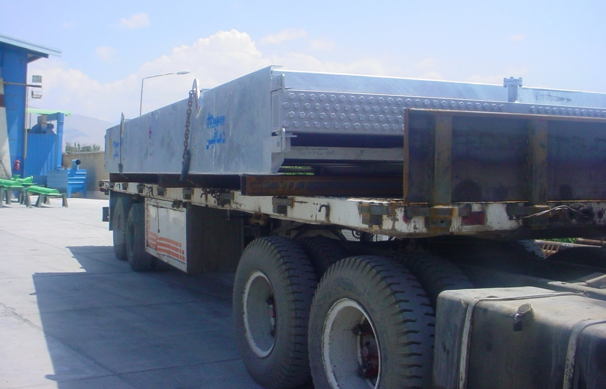
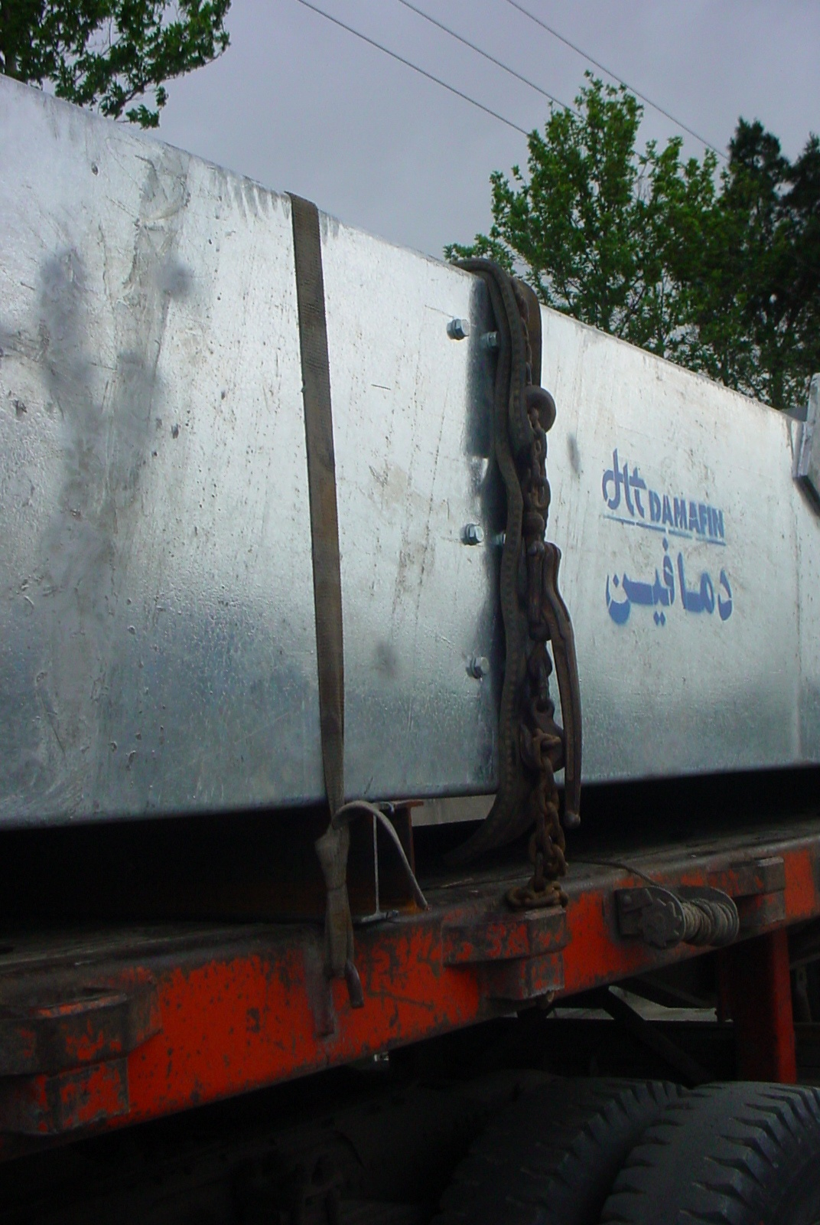

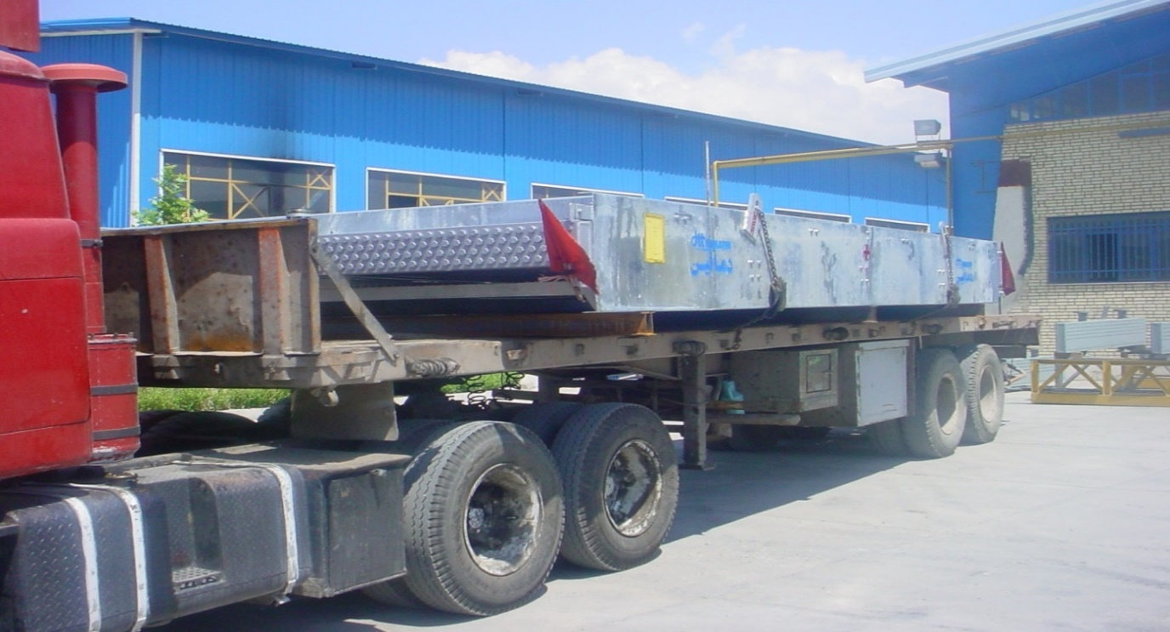

7. PACKING PROCEDURE FOR STRUCTURAL PARTS
All small structural parts together with belt and spanner and then fix in the pallets. and large parts like columns or fan ring parts will be fix in pallets separately. (As shown in below pictures).
- Columns, walkways, ladders are packed with proper observance of the color protection quality and depending on the dimensions of the equipment.

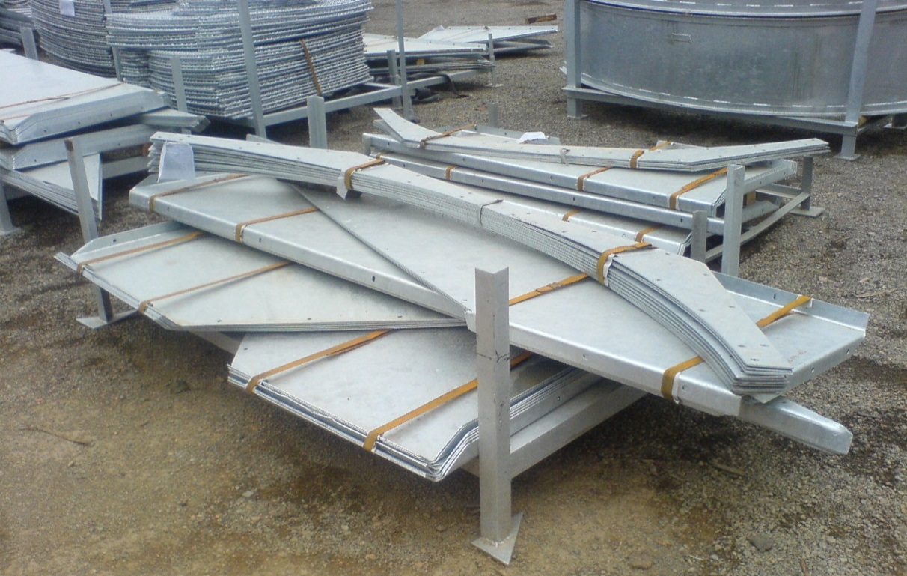

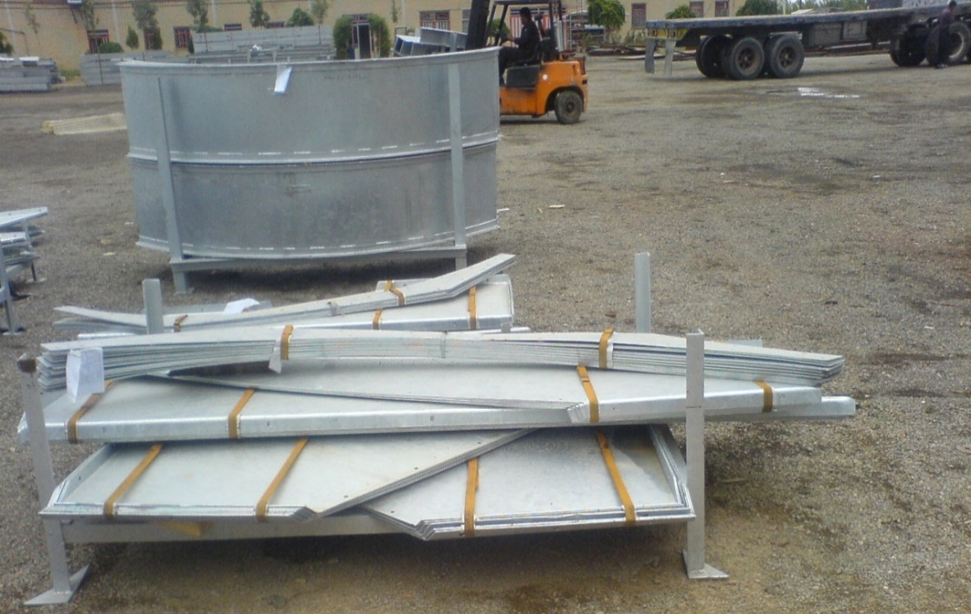

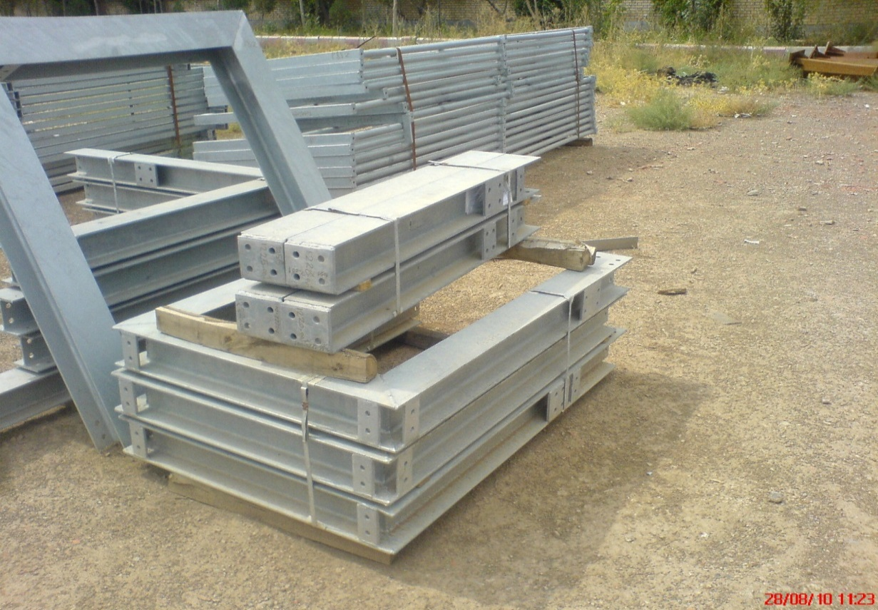

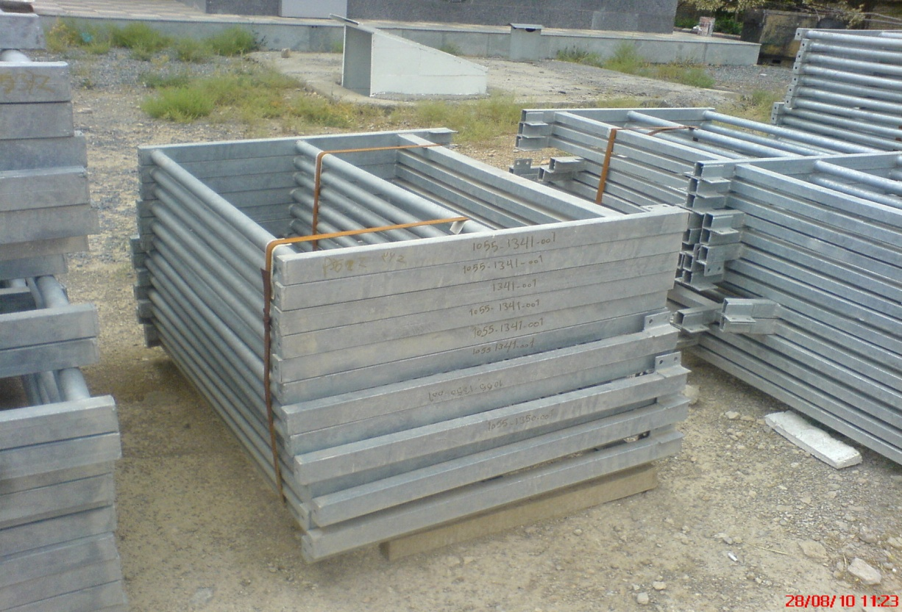

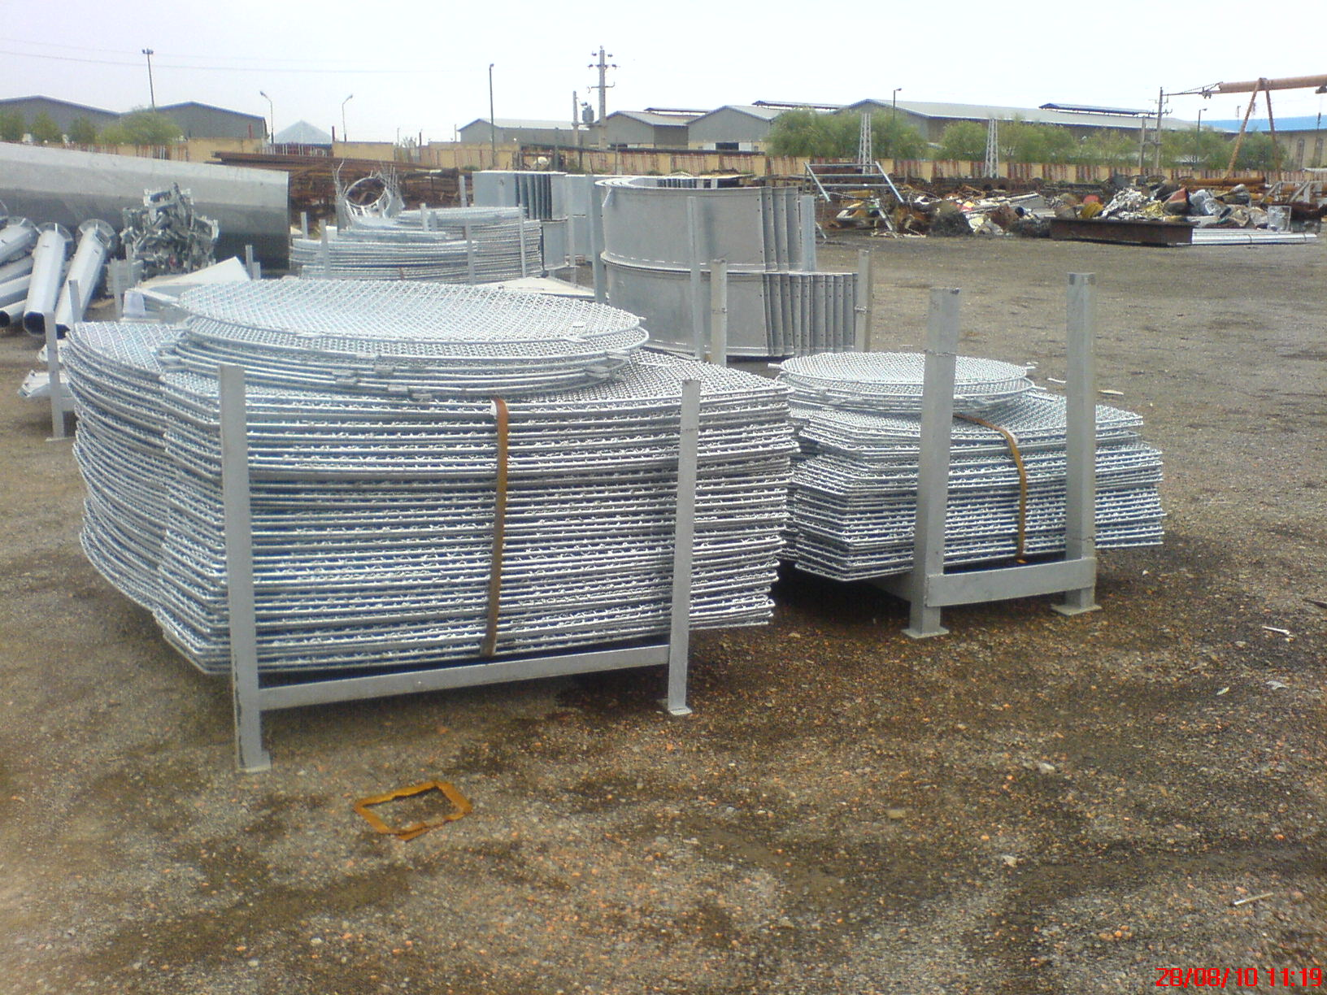

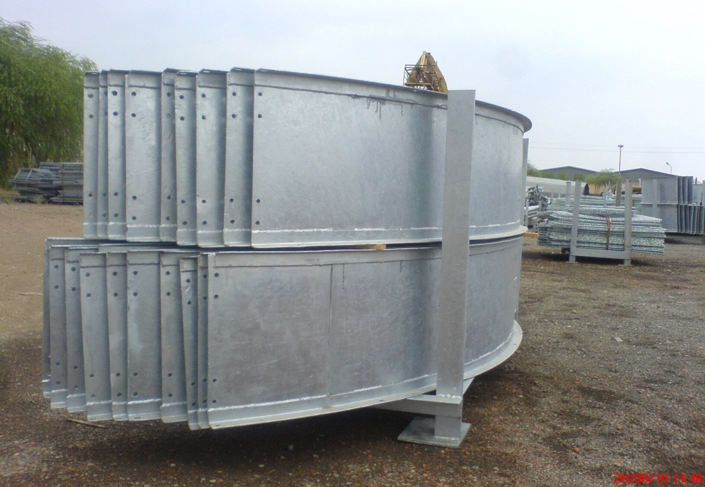

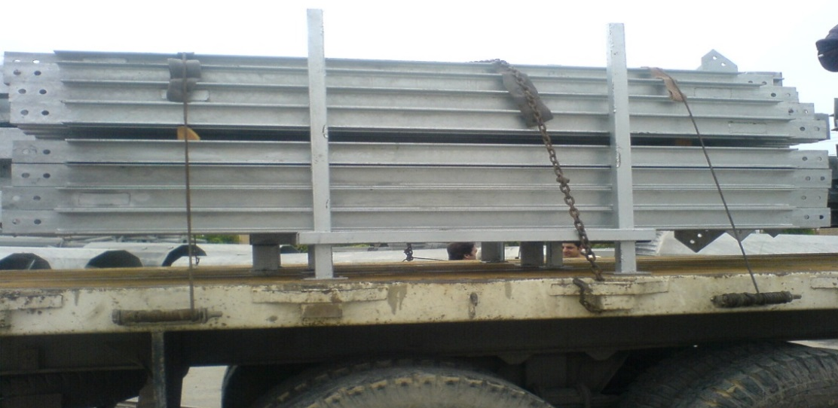

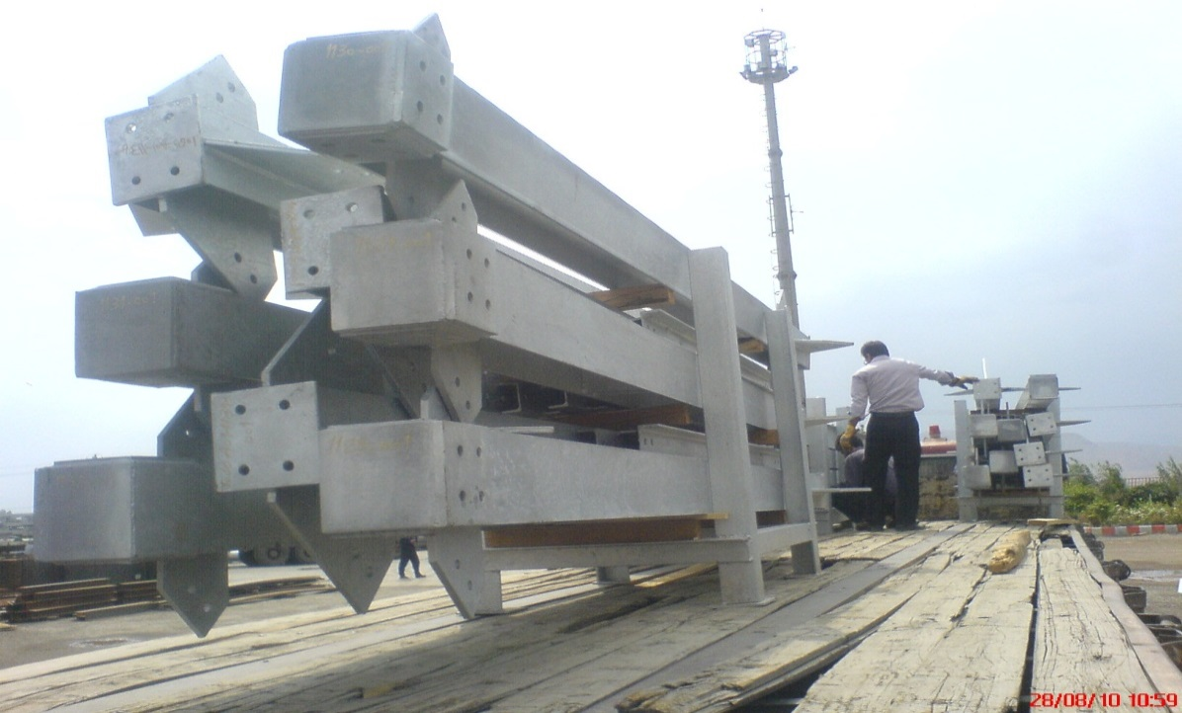

8. Small Parts, Tools and spare Parts
Small loose parts shall be tagged and packed in a separate, sturdy wooden box; any such box shall be shipped with main equipment being securely attached to the main skid or within the main box.

- Format

