Letter: 2025-DMF-150725
Date: 15-Jul-2025

ATTN TO: Mr. Mirzaian
Damafin Managing Director

Subject: Closure of contract based on mutual agreement Purchase Orders No. ENER-DMF-2024-100-003& ENER-DMF-2024-100-003-A1

Dear Sir,

With reference to mutual agreements between parties purchase orders No. ENER-DMF-2024-100-003& ENER-DMF-2024-100-003-A1 will be closed between parties by return of all received payments (71,000.00 Euro) to the buyer representative (Mr. Farbod Mostafavi Naeeni, Mobile Number: +971 50 191 0069) as per below information and ID Card provided:

Mr. Farbod Mostafavi Naeeni,
Mob: +971 50 191 0069
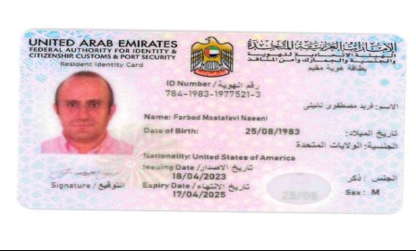
Considering Damafin payment in AED currency in UAE, please note the amount to be paid as per xe.com rate at the date of payment.

Best regards,
Ener Teknoloji Management

