PURCHASE ORDER

SELLER | : |  | PURCHASE ORDER No.:  ENER-NASH-2025-PO-200  ISSUE DATE: 22-Feb-2025
  NASH Engineering FZCO
Add. | : | PO. BOX. 261430, Jebel-Ali Free  Zone, Dubai, U.A.E
Tel. | : | +971 48861773


P.O. number must be shown on all shipping packages, shipping documents, invoices and correspondence in connection with this PURCHASE ORDER.

This PURCHASE ORDER is subject to the descriptions, terms, conditions and instructions stipulated hereunder and attachments hereto, if any.

SUBJECT: Instrumentation work and supports fabrication for compressor skids as per Quotation NASH/21992/2024/R1 dated 21.02.2025 and relevant emails including all technical details, clarification and comments discussed and agreed between parties.

This PURCHASE ORDER, together with all its attachments shall be referred to as “CONTRACT
No. ENER-NASH-2025-PO-200.
In the event of any inconsistency between the matters contained in the CONTRACT, the portions shall govern in the order of following precedence. The first named being paramount.

- PURCHASE ORDER
- Attachments PURCHASE ORDER

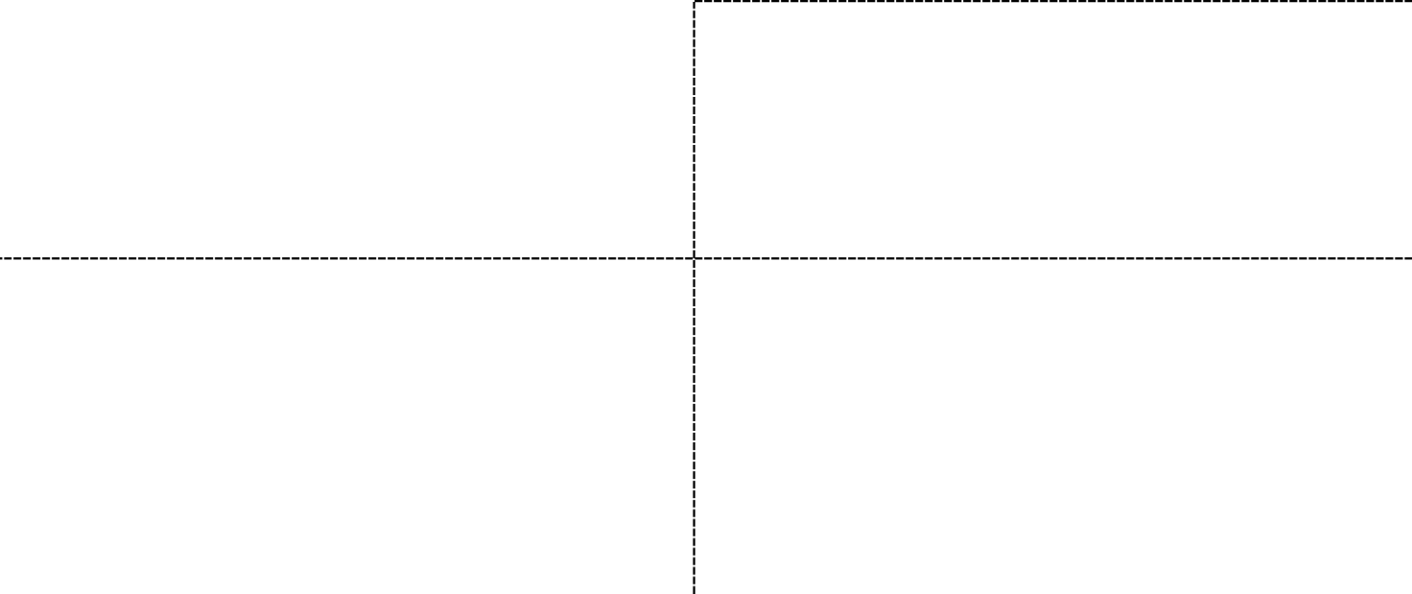  Page 1 of 4  SELLER’S ACCEPTANCE:  Nash Engineering FZCO.  PO. BOX. 261430 | BUYER:  ENERPROCESS FZ-LLC
Jebel-Ali Free Zone, Dubai, U.A.E | P.O. BOX 54518, Compass Bldg. Al Shohada Road  Al Hamra Industrial Zone-FZ, Ras Al Khaimah  United Arab Emirates (U.A.E)
Name(s) / Title(s): | Name / Title: Managing Director
Seal & Sign: Date: | Seal & Sign: Date:

Reference Correspondence (with order of priority)

  - This PO and BUYER Material Requisition

  - SELLER’s Clarifications Letter(s):
    - No.: Latest Communications by Email.

  - SELLER’s Commercial Quotation:
    - Quotation NASH/21992/2024/R1 dated 21.02.2025 for Instrumentation work and supports fabrication for compressor skids with Comments Made and clarification emails

Attachments

  - SELLER’s Quotation NASH/21992/2024/R1 dated 21.02.2025 for Instrumentation work and supports fabrication for compressor skids.
  - Project 3D Model.
  - Project Painting Procedure.
  - PID.
  - GAD.
  - Instrument Cable List.
  - Instrument Hook-up and MTO.
  - Instrument List.
  - Local Panel and Junction Box Wiring Diagrams.
  - Compressor support.
  - JB support.
  - Tubing orthos and supports.

Price

  - Total FCA NASH Engineering FZCO Facilities in Jebel Ali (according to Incoterms 2020) price of Equipment subject to this PURCHASE ORDER, based on FCA/ NASH/ Jebel Ali (Loaded on truck) delivery term amounts to be 19,470.00 USD based on relevant unit price(s) mentioned under SELLER COMMERCIAL QUOTATION of this PURCHASE ORDER.

  - The unit price(s) shall be fixed and firm for the duration of CONTRACT and shall not be subject to escalation.

Payment

  - 25% of PURCHASE ORDER price shall be paid upon PO countersign
  - 25% of PURCHASE ORDER price shall be paid upon Receipt of all Free Issued Items from Buyer
  - 40% of PURCHASE ORDER price shall be paid upon Completion of E&I Works and Supports Fabrication and complete assembly approved by buyer representative.
  - 10% Upon client sign off for Ex-works readiness & Issue of IRN.

Test and Inspection

  - The procedure and schedule for test and inspection shall comply with vendor’s technical documents specified in SELLER’s procedure approved by BUYER.
  - SELLER should send Inspection notification 14 Calendar days prior to inspection date.
  - SELLER Confirmed Material used for this project will not be China/India Origin

Packing and marking

  - Marking to be according to buyer instruction

Delivery
  - All Equipment shall be delivered within 4 weeks (FCA Nash/Jebel Ali Loaded on Truck) from Effective Date of PURCHASE ORDER.
  - Partial delivery is NOT allowed.

Guarantee Period

The Guarantee Period for the subject scope of work shall be 24 months after delivery.

Liquidated Damage

SELLER undertakes to deliver the subject Equipment within the period stipulated under Clause
  - of this PURCHASE ORDER. In the event of any delay beyond the delivery period for reasons attributed to the SELLER, SELLER shall pay the following amounts to BUYER as liquidated damage:

  - The liquidated damage for every full week delay is 0.5% of the PURCHASE ORDER PRICE.

  - Maximum liquidated damage is 5% of the PURCHASE ORDER price. In Case of delay by parts Manufacturer, this delay will be considered as an acceptable, delay and not subject to this article.

  - BUYER has the right to deduct the applicable liquidated damages from any SELLER’s entitlements.

Effective Date of the PURCHASE ORDER

Upon countersigning of this PURCHASE ORDER and fulfillment of the following conditions, this PURCHASE ORDER shall become effective:

  - Upon Countersign of the Purchase Order

- Arbitration:
Any dispute arising out of or in connection with the Contract, which cannot be settled amicably by the parties in accordance with the provisions of the Contract, shall be finally settled under the Rules of DIAC Court based on UAE laws and regulations. The arbitration shall be conducted in English at a location agreed upon between the parties, and the arbitral award shall be final and binding on both parties without any right of appeal for any party.
The arbitral award shall also determine the expenses of the arbitration and the party, which shall bear them or the proportion of such expenses to be borne by each party.
Arbitration shall not prevent Seller from continuation of the works.

- Governing Law:

This Contract shall be governed by and interpreted in accordance with the Laws of UAE.

